Name

Mathematics Stage 5 Core
Bivariate Data Analysis

Book 1 | Datasets involving 2 variables  Line of best fit  Regression modelling | Version: 260613  Feedback:  https://MrDingMaths.com
Contents
Syllabus Content 2
Learning Intention 3

Syllabus Content
MA5-DAT-C-02 displays and interprets datasets involving bivariate data
Identify and describe numerical datasets involving 2 variables
- Distinguish between situations involving 1-variable and 2-variable (bivariate) data and explain when each is needed
- Explain the difference between variables that have an association and variables that have a causal relationship
- Identify and describe the independent variable and dependent variable in relationships with possible cause and effect
Represent datasets involving 2 numerical variables, using a scatter plot and a line of best fit, by eye
- Gather data on a topic of interest involving 2 numerical variables
- Represent the data using a scatter plot
- Create a line of best fit, by eye, on an existing scatter plot
Interpret data involving 2 numerical variables, using graphical representations
- Describe informally the association between 2 numerical variables and apply terminology about form (linear), strength (strong, moderate or weak) and direction (positive or negative)
- Use the line of best fit, by eye, to make predictions between known data values (interpolation) and what might happen beyond known data values (extrapolation)
- Explain the limitations of the model when making predictions

Bivariate Data

- Independent and Dependent Variables
Univariate data counts the frequency of a single variable.
Bivariate data explores relationships between two variables.
The independent variable often causes changes in the dependent variable, but not always.
For example, for a relationship between maths test scores and hours spent on social media, Mr Ding’s hypothesis might be that more hours on social media mean lower test scores.
- The independent variable would be hours on social media.
- The dependent variable would be maths test score.

- Identify independent and dependent variables
- Cathy wants to investigate if there is a relationship between a person’s age and their height.  Independent variable:  Dependent variable: | - Mika wants to investigate how the amount of sugar in a person’s diet affects the size of their waistline.  Independent variable:  Dependent variable:
- Jelena is looking into the relationship between an NBL player’s average points scored and their height.  Independent variable:  Dependent variable: | - Jeremy is investigating how fuel consumption is affected by the size of a car.  Independent variable:  Dependent variable:
- Hugo is looking into the relationship between a students’ height and the time taken to run 100 m.  Independent variable:  Dependent variable: | - Shirley is examining the relationship between exam marks and hours spent watching TV shows.  Independent variable:  Dependent variable:

- Correlation is not Causation
- Correlation is when two things change together in a pattern. If one thing goes up and the other usually goes up too (or down), they're correlated. It's like they're connected.
- Strong correlation between variables doesn’t prove causation without randomised controlled trials (the type of experiments you do in science).
- Proving causation requires the scientific method.

- Investigation Correlation is not causation
Consider the relationship between ice cream sales and shark attacks.
The first graph is a line graph, the second is a scatterplot.
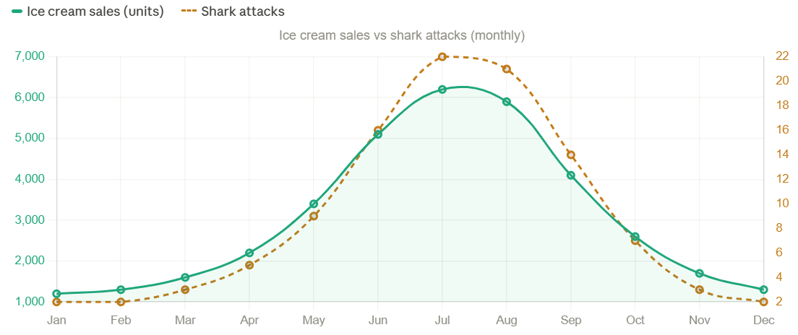

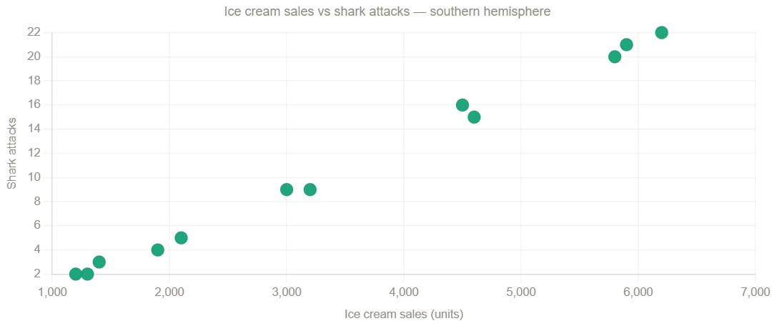

What do you notice about the relationship between ice cream sales and shark attacks?

Can you conclude that selling more ice cream causes more shark attacks?

- Investigation Correlation is not causation
- Each pair of variables has a correlation.
Which ones are likely to have a causal relationship?

  - Temperature and ice cream sales
  - Ice cream sales and number of sunburns reported
  - Reading skills of children and shoe size
  - Number of books in a home and family income
  - Number of cashiers and average checkout time in a supermarket
  - Number of patients in a hospital emergency room and waiting time
  - Number of computers and number of TVs in a home
  - Loan interest rate and size of monthly repayments
  - Driving speed of a vehicle and time taken to arrive home
  - Maths test mark and English test mark
  - Number of storks and birth rate in a region
  - Proportion of smokers in a population and incidence of lung cancer
  - Social media use and short attention spans

A, E, F, H, I, L

Scatterplots

- Scatterplots
A scatterplot shows two variables on a Cartesian Plane.
A bivariate data point $(x,y)$ has two parts:
- $x$ is the independent variable.
- $y$ is the dependent variable.

- Guided Practice Plotting scatterplots
The heights and weights of 8 students were measured and the results shown in the table.

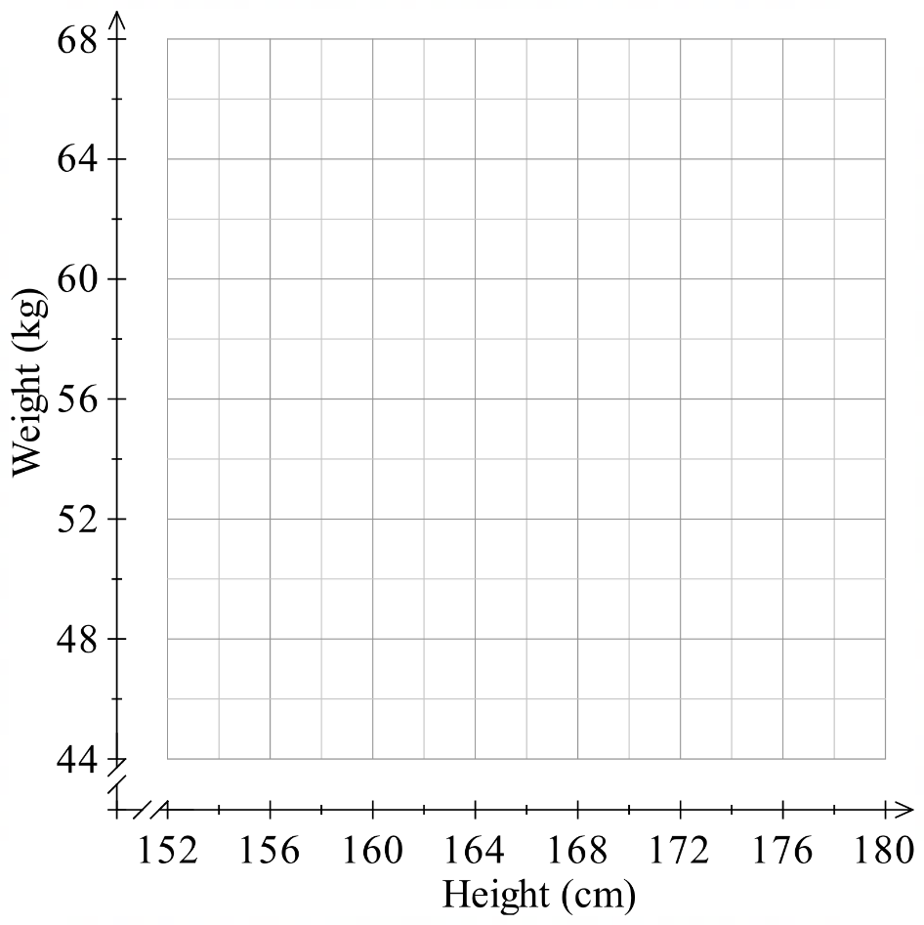
Plot this data as a scatterplot.

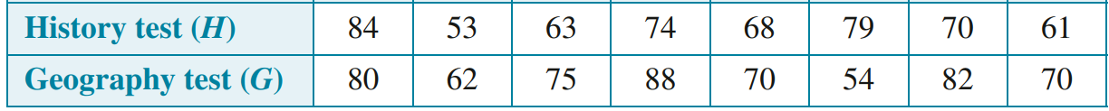
The test results of 8 students are shown.

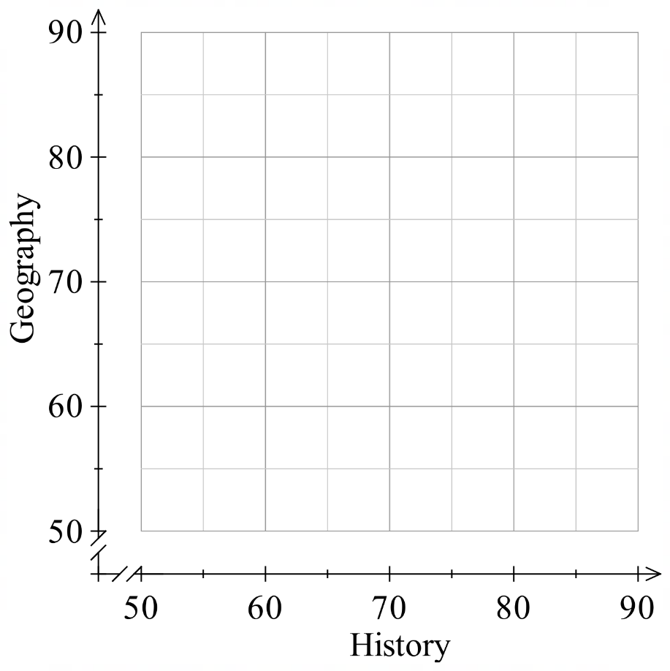

Plot the data as a scatterplot

- Interpreting Scatterplots
In describing relationships, we use hedging language to express that there are exceptions:
‘older people tend to be smarter’ rather than ‘older people are smarter’

- Example Interpret scatterplots
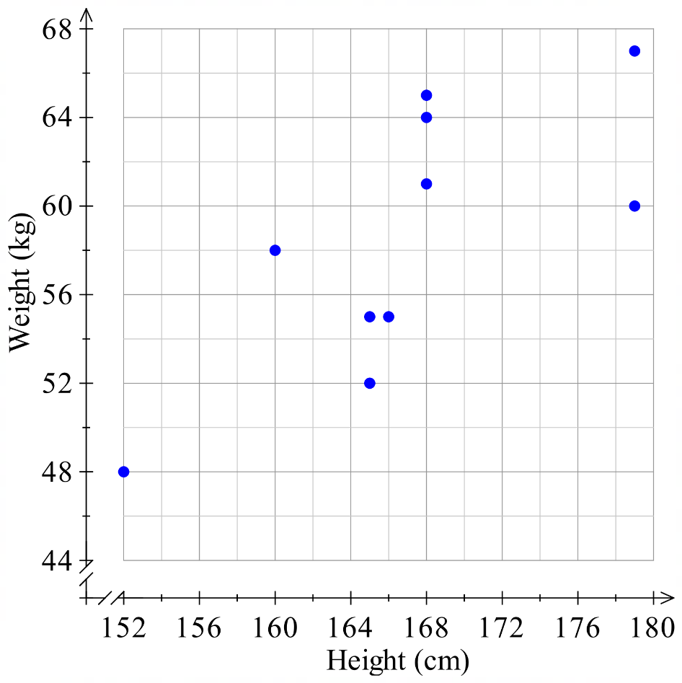
Consider the scatterplot.
What was the height of the person who was 48 kg?
152 cm
What were the weights of the people who were 168 cm?
61 kg, 64 kg, 65 kg
Describe the relationship between height and weight.
Taller people tend to weigh more
Are taller people always heavier than shorter people?
No

- Guided Practice
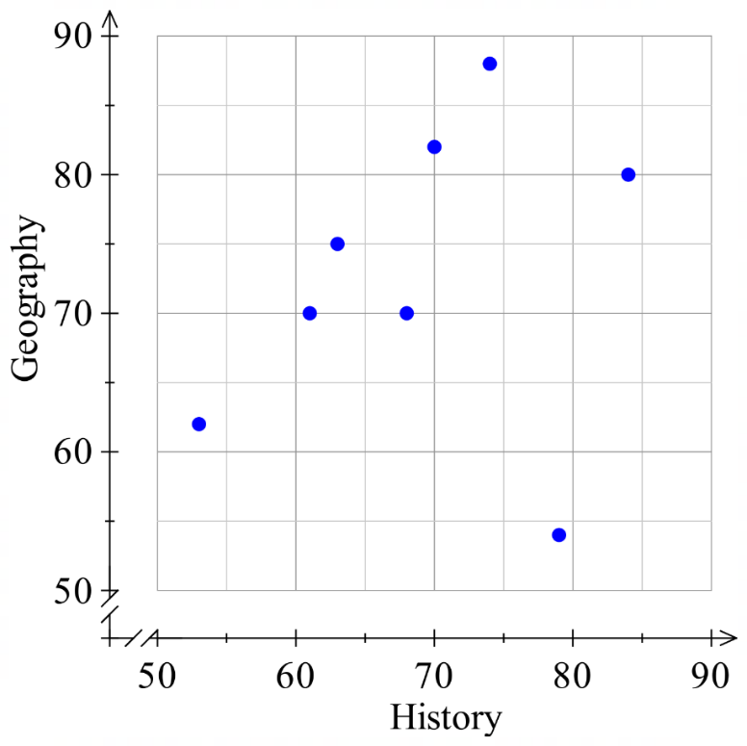
What was the history mark of the person who scored 80 in geography?
84

What was the geography mark of the person who scored 53 in history?

62
Describe the relationship between history mark and geography mark.

People with higher history marks tend to have higher geography marks

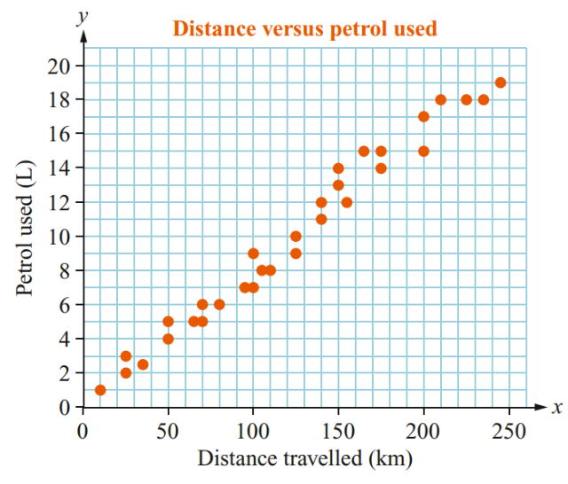
How much petrol was used to travel 210 km?
18 L

How far was travelled using 19 L?

245 km
Describe the relationship between distance travelled and petrol used.

Travelling a longer distance tends to use more petrol.

Foundation
- The scatterplot shows the head height to age for 10 people.
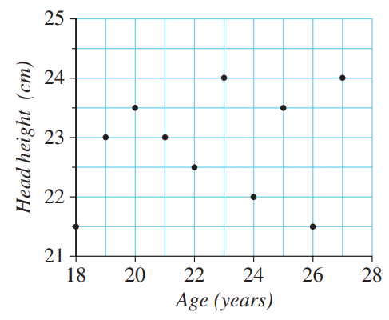
  - What is the head height for the person who is
21 years old?
23 cm
  - What is the age of the person who has a head
height of 22 cm?
24 years old
  - What is the greatest head height?
24 cm
  - What is the age of the youngest person?
18 years old
  - How many people have a head height greater than 23 cm?
4 people
  - Is there a clear relationship between these two variables?
no

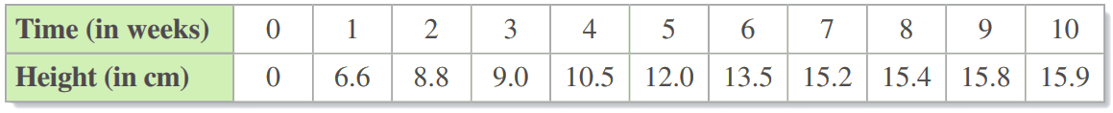
- The table shows the height in cm of a eucalypt tree seedling as it grows.

  - Plot the data as a scatterplot.
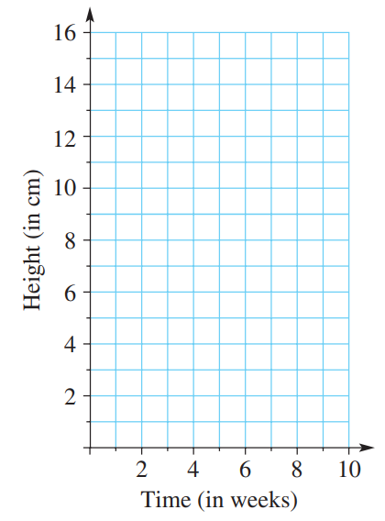
  - What is the increase in the height of the seedling between week 1 and 2?
2.2 cm
  - What is the increase in the height of the seedling during the last week?
0.1 cm
  - How many weeks does it take for the seedling to increase in height from 9 cm to 12 cm?
2 weeks
  - Estimate the height of the seedling after 4.5 weeks.
$≈$ 11 cm
  - Estimate the time taken for the seedling to grow to a height of 14 cm.
$≈$ 6.5 weeks

Development
- The maximum wind speed and maximum temperature in a location were recorded for 2 weeks. The data is displayed in the table below.
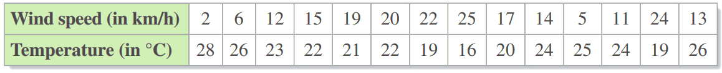
  - Construct a scatterplot of the data given in the table.

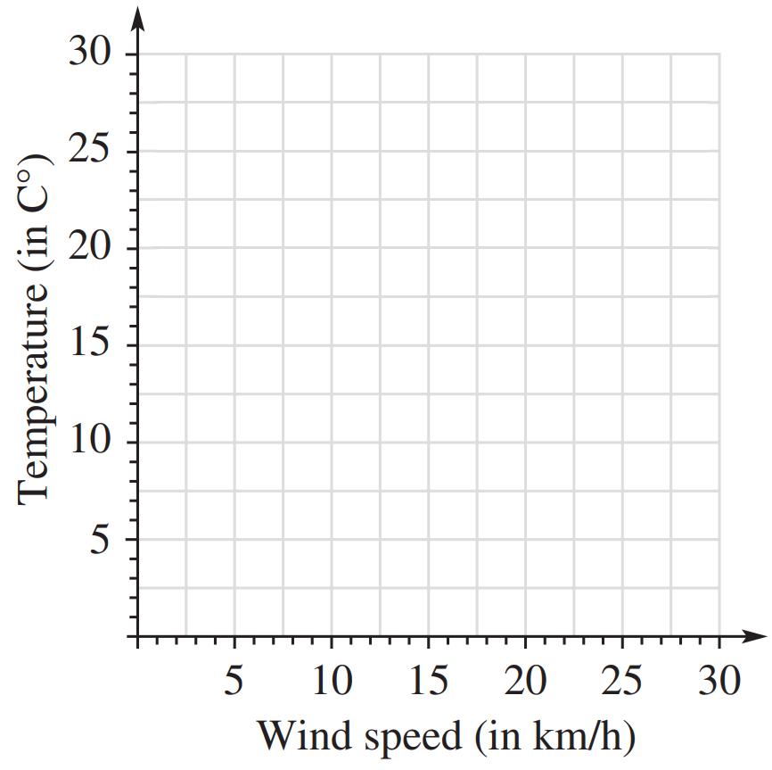
  - Are there any conclusions to be drawn from the scatterplot?

As wind speed increases, temperature tends to decrease.

- The table shows the number of runs scored and the number of balls faced by batsmen in a one-day cricket match.
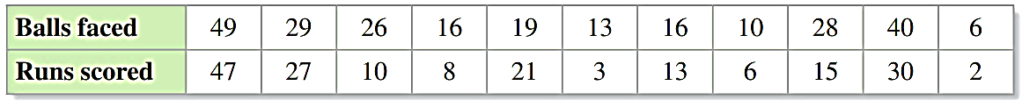
  - Construct a scatterplot of the data given in the table.

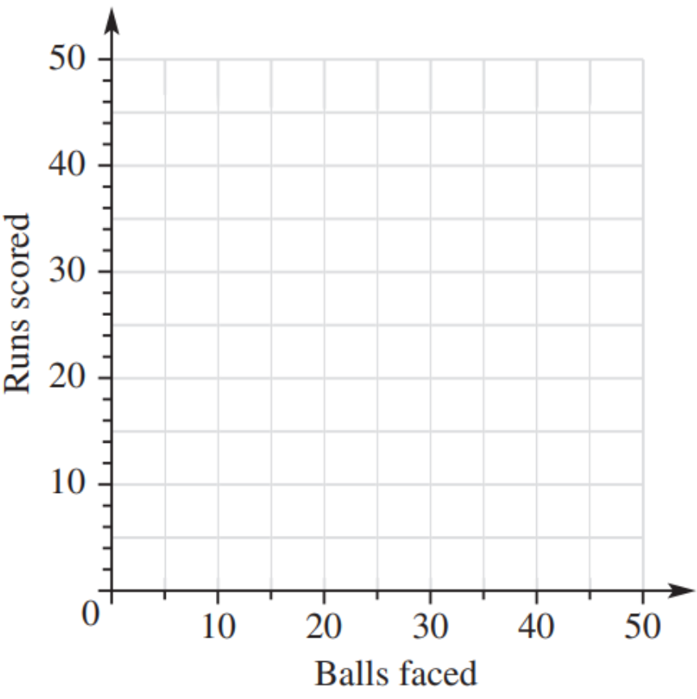
  - Are there any conclusions to be drawn from the scatterplot?

As balls faced increases the
number of runs tends to increase.

Drawing a Line of Best Fit

- Line of Best Fit
A line of best fit:
- Represents most of the points as closely as possible.
- Goes through as many points as possible.
- Has roughly the same number of points above and below it.
- Is drawn so that the distances of points from the line are as small as possible.

- Do NOT extend the line past existing data points, as the relationship may not continue outside of this range.
- A line of best fit may not “fit” the data nicely if there is an outlier.

A line of best fit is also referred to as a regression line, if it was generated using a special method using a computer.

- Construct A line of best fit
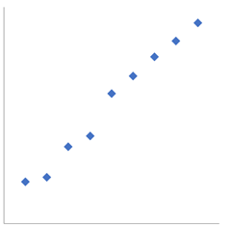 | 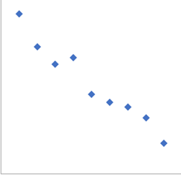 | 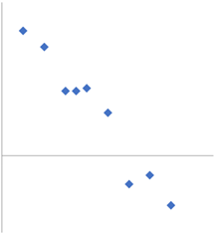
Decide whether these lines of best fit are appropriate
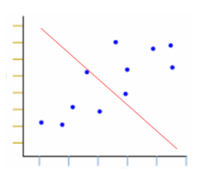 | 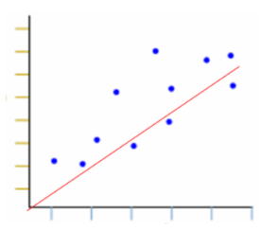 | 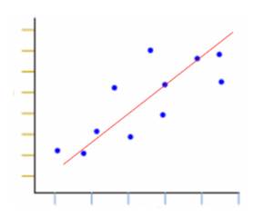
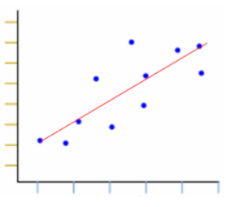 |  | 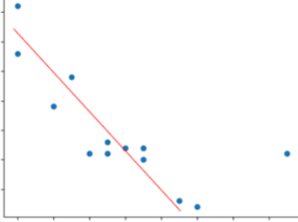  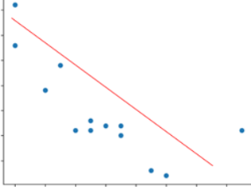

Foundation
- Sketch lines of best fit to these scatterplots.
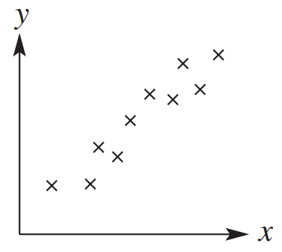 | 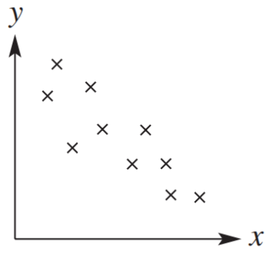 | 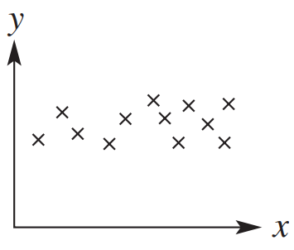

- Draw a line of best fit on these scatterplots.
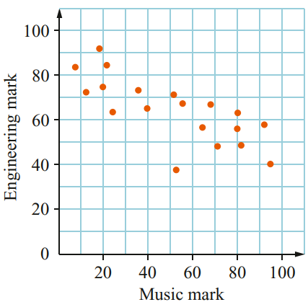 |  | 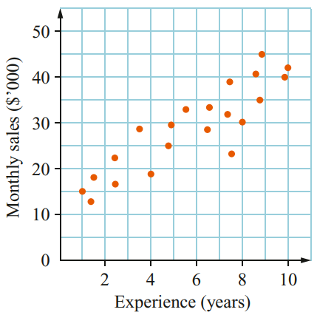  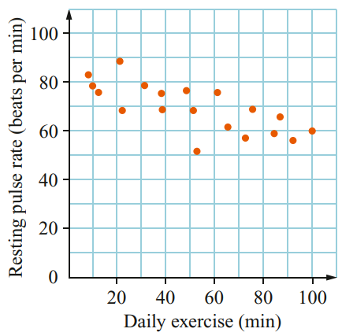

- Explain why these are not lines of best fit.
Does not fit the data | 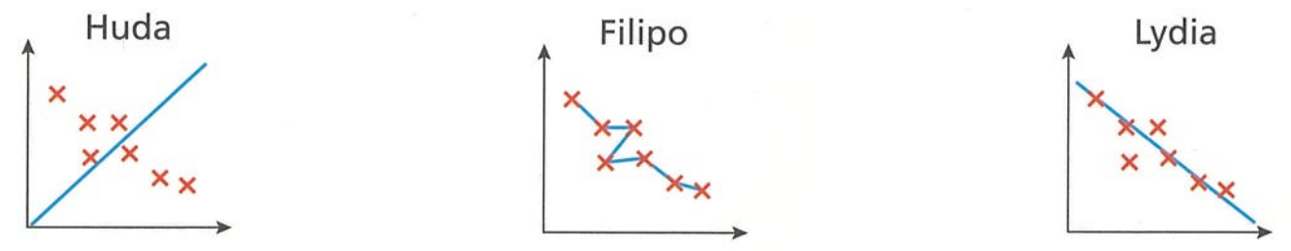  The line of best fit is a single straight line | The line extends past the data.
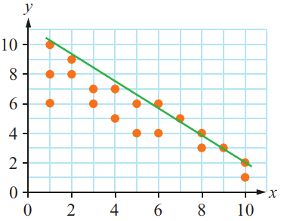  Too many datapoints below line of best fit. | 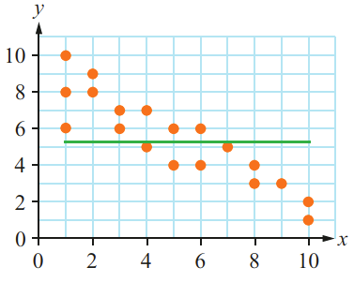  Doesn’t fit the data.

Development
- Outliers can have a large impact on the line of best fit.
Consider the dataset below. A computer was used to generate the line of best fit.
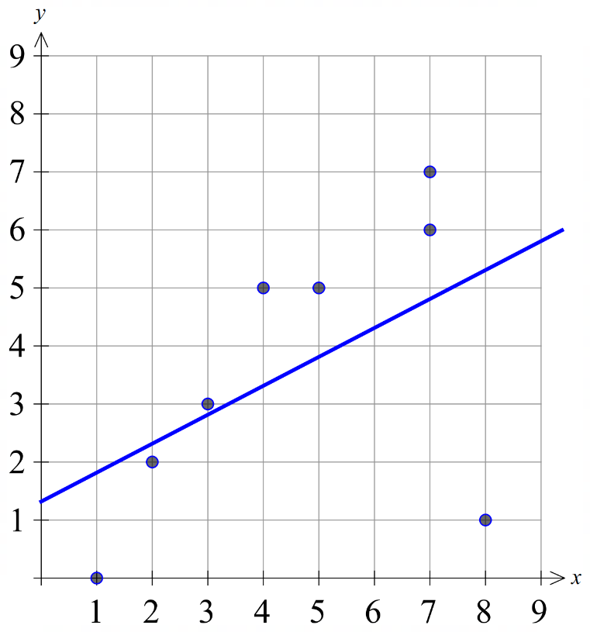
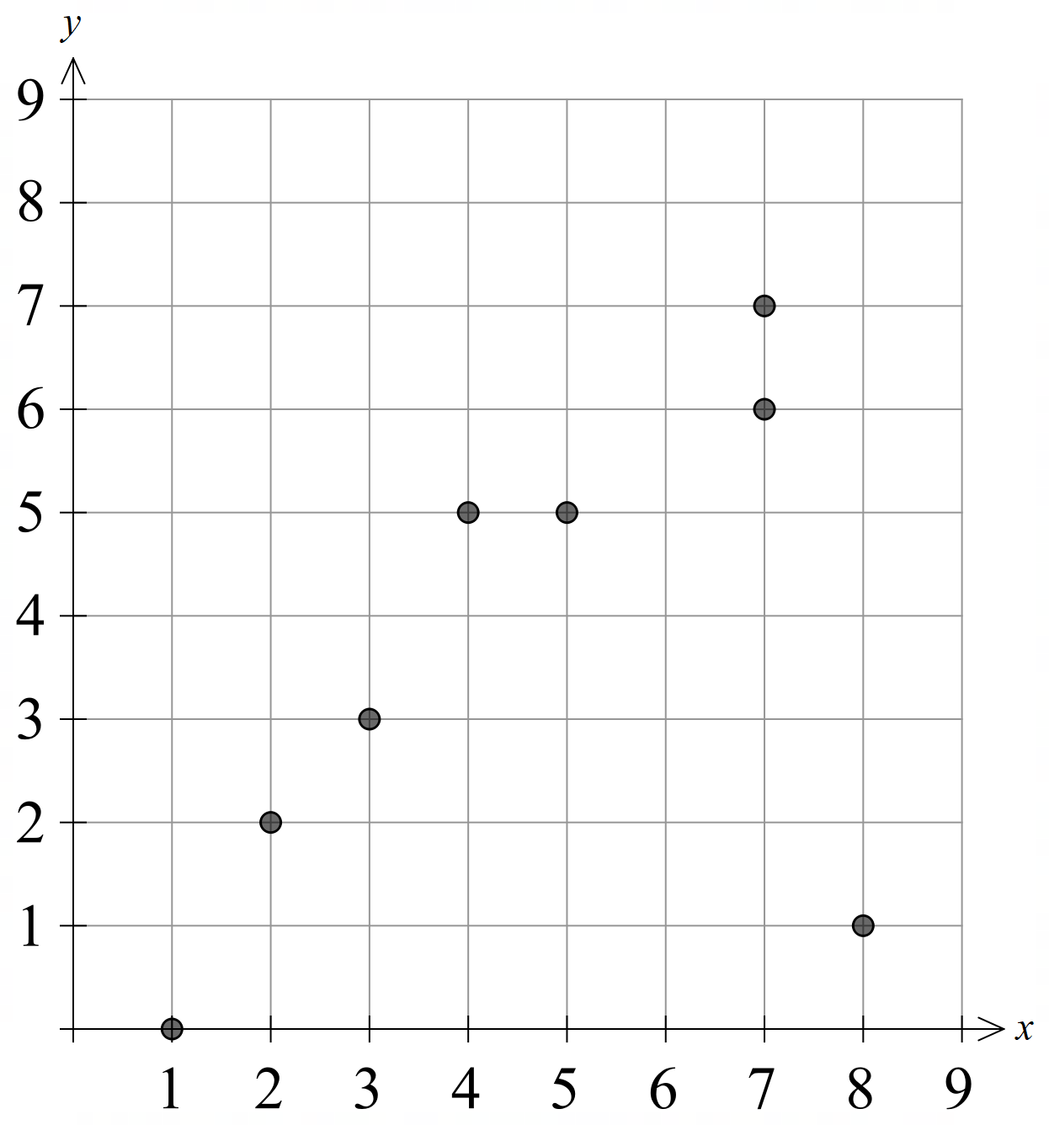

Complete the sentences:
The line of best fit doesn’t seem to fit the data nicely. This is because of the outlier: (……, ……).
(8,1)
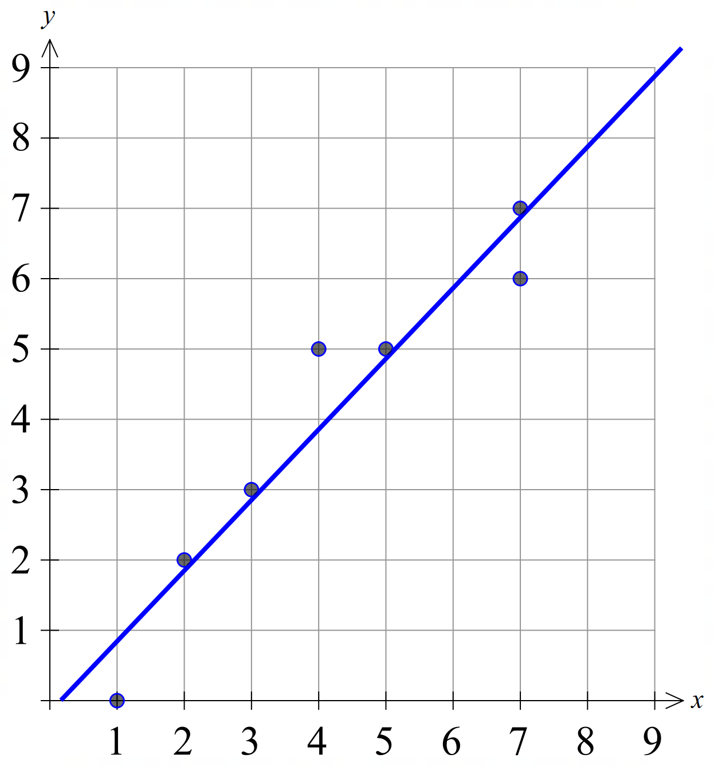
The outlier is causing the gradient of the line of best fit to be ………… steep than expected.
less
If we remove the outlier, the gradient of the line of best fit is ………………, and fits the data better.
steeper

- A survey collected data on cars with a 50 L petrol tank.
It compared distance driven and litres of petrol remaining in the tank.
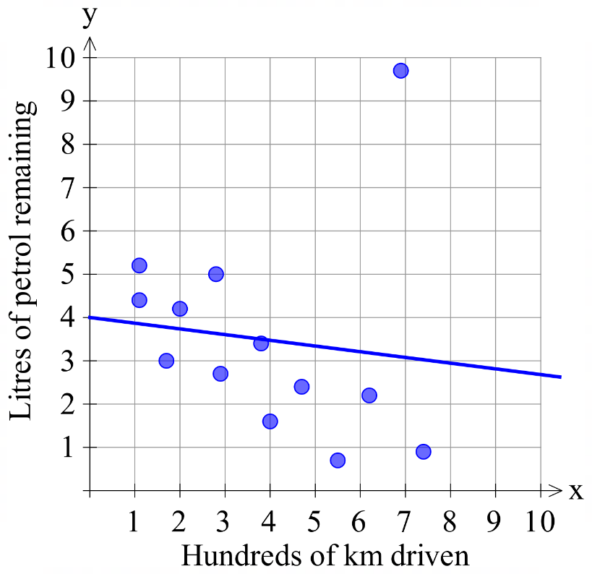
x Identify the outlier. Circle the data point.
(6.9,9.8)
If the outlier were removed, what would happen to the gradient of the line of best fit? Would it be steeper or less steep?

The gradient of the line of best fit would become more negative and steeper.

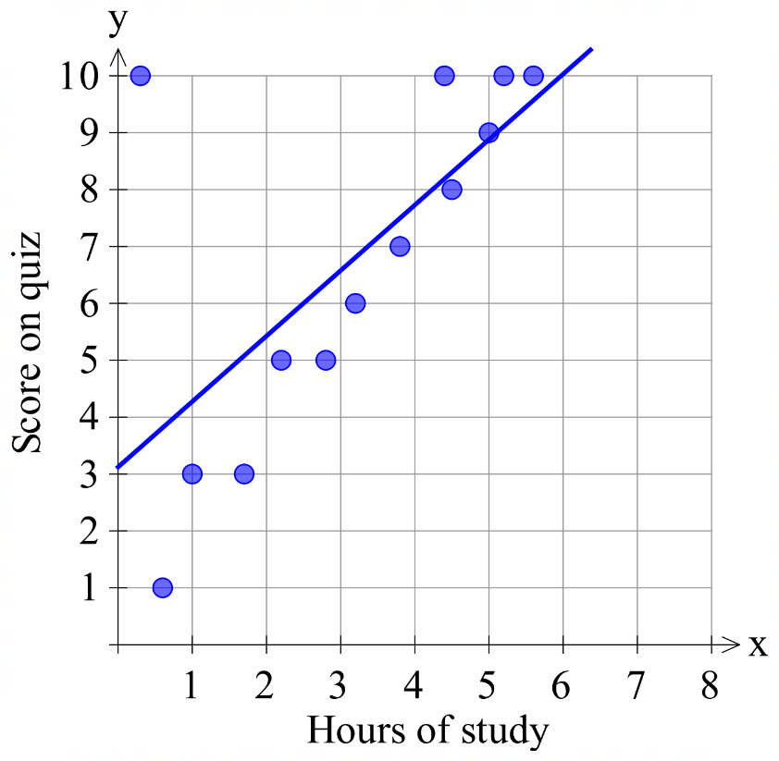
- A survey collected data on hours studying and score on quiz.
Identify the outlier. Circle the data point.

(0.3, 10)
If the outlier were removed, what would happen to the gradient of the line of best fit? Would it be steeper or less steep?

The gradient of the line of best fit would become more positive, and steeper.

Correlation

- Association and Correlation
An association is a relationship between two variables.
A linear association is called a correlation.

Linear (Correlation) | Non-Linear
The data points loosely form a straight line. | 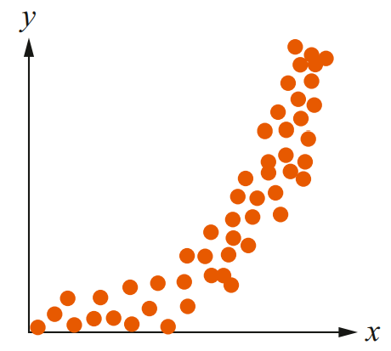  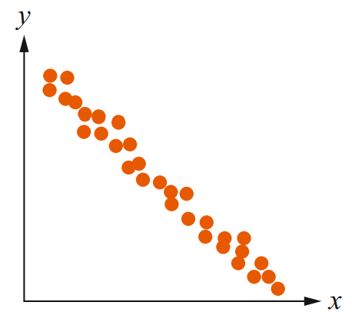  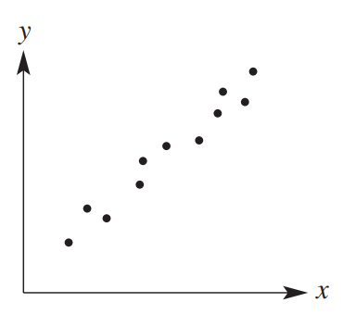  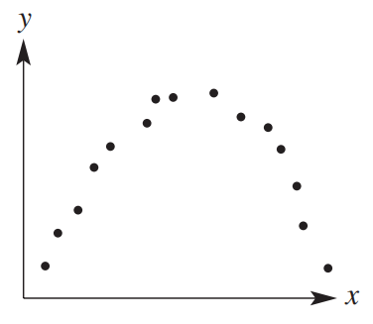  The data points don’t form a straight line

- Direction of a Correlation
Positive | Negative
Positive gradient for a line of best fit. | 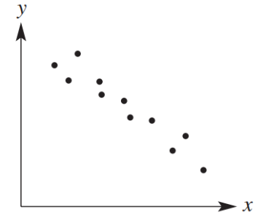  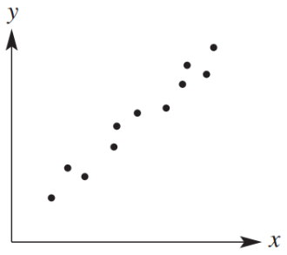  Negative gradient for a line of best fit.

- Strength of a Correlation
Strong | Moderate | Weak
Data points form a clear line with not much random scatter.  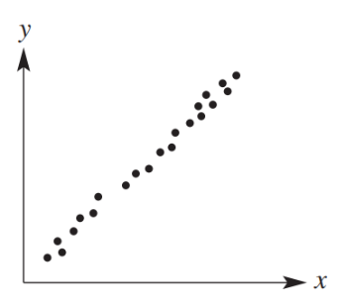 | Between strong and weak  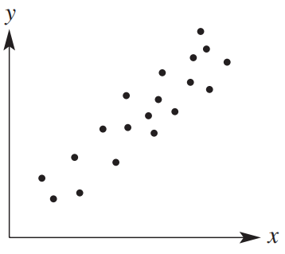 | 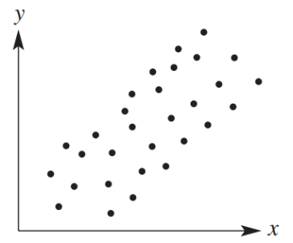  Data points are significantly scattered and do not form a neat line.

- Identify direction and strength of a correlation
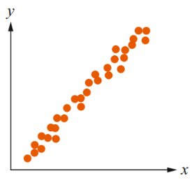  Direction:  Strength: | 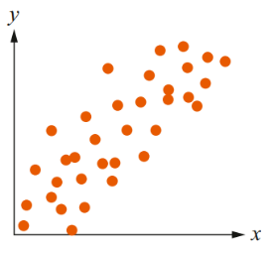  Direction:  Strength: | 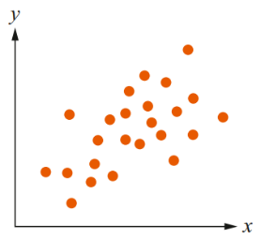  Direction:  Strength:
Direction:  Strength: | 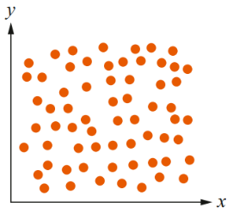  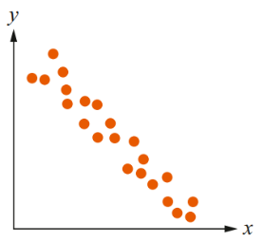  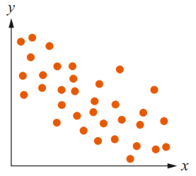  Direction:  Strength: | Direction:  Strength:

- Key Ideas
- An association is a relationship between two variables.
- If the data points are scattered completely randomly, then there is ………… association.
- We call a ……………… association a correlation.
- The direction of a correlation can be positive or negative, based on the ……………… of the line of best fit.
- The strength of a correlation describes how …………………… the dots are from the line of best fit.

Foundation
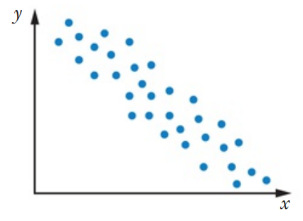
  - As the value of $x$ increases, the value of $y$ ……………
decreases
  - What correlation is shown on the scatterplot? Positive or negative?
negative
- For each scatterplot, state whether the correlation is positive, negative, or zero.
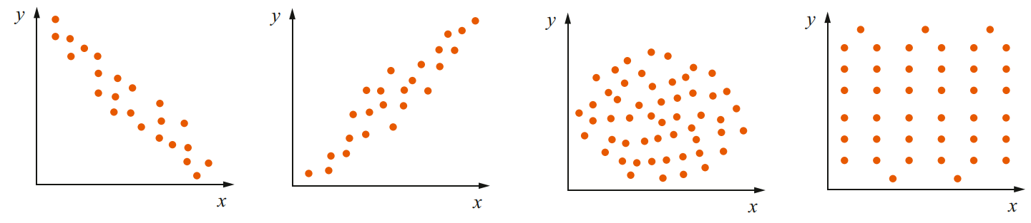  negative | positive | zero | zero

- For each scatterplot, state whether the correlation is perfect, strong, or moderate, weak, or no correlation.
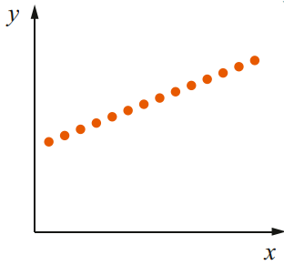  perfect | 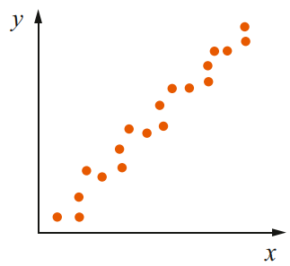  strong | 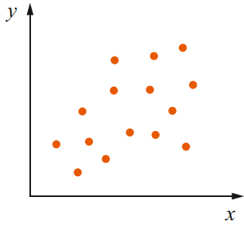  weak | 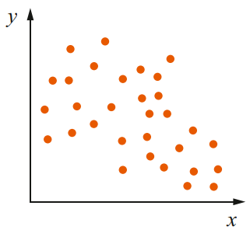  No correlation

- State whether the correlation in these scatterplots is positive/negative or strong/moderate/weak.
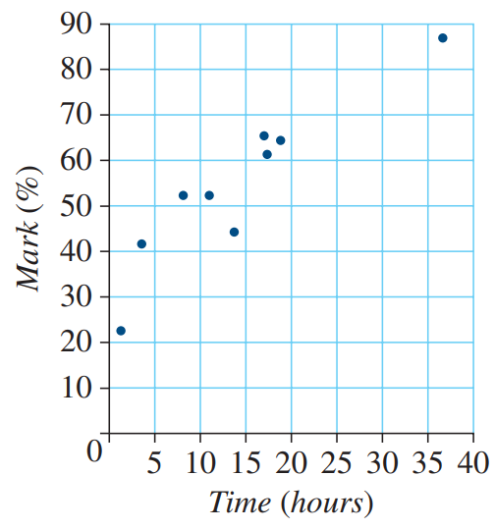  Positive moderate | 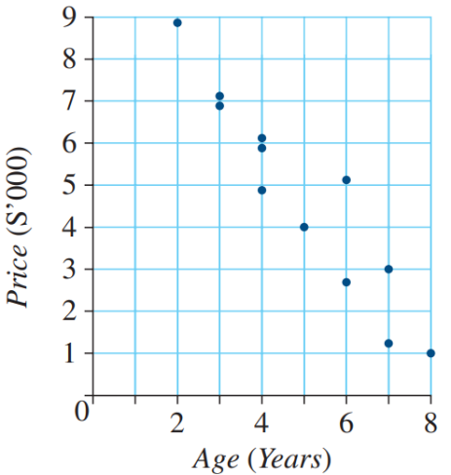  Negative strong/moderate | 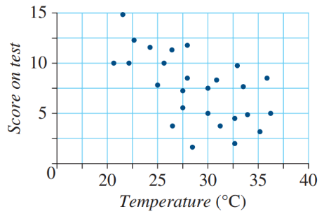  Negative weak

- If two variables have a strong correlation, will the data points be closer to or further from the line of best fit than with a weak correlation?
closer

Development
- Draw a scatterplot with these correlations.
- strong positive  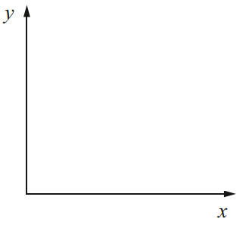 | - weak negative | - perfect negative
- no correlation | - perfect positive | - moderate negative

- Show the table as a scatterplot.

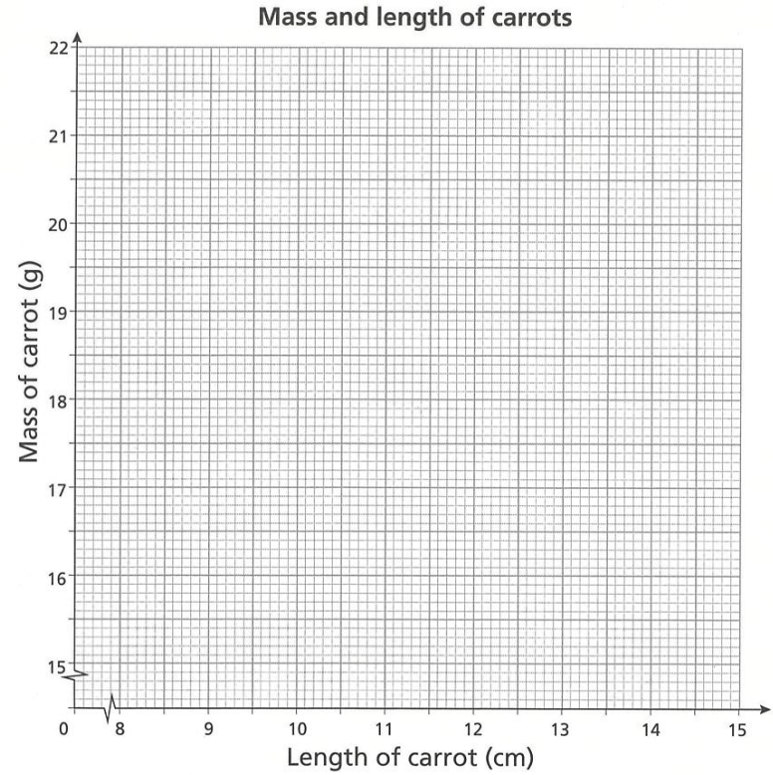
  - Describe the relationship between the length of a carrot and the mass of a carrot.

The longer the carrot, the greater its mass.
  - What is the direction of the correlation shown by the scatterplot?

positive
  - Why might a longer carrot have a lower mass than a shorter carrot?

A longer carrot might be thinner.

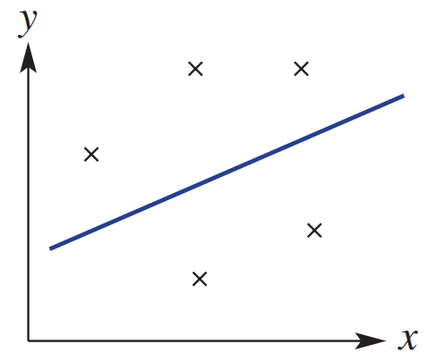
- Explain why the shown line of best fits would not be appropriate for the data.
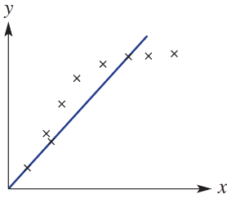

The form of the association is not linear
- Predict whether each pair of variables have a positive, negative or zero correlation.
  - number of alcoholic drinks consumed and reaction time. ………………………
negative
  - number of cigarettes smoked and probability of lung cancer. ………………………
positive
  - price of a packet of biscuits and the change from $10. ………………………
negative
  - number of road accidents and number of ambulances on the road. ………………………
positive
  - size of back muscles and swimming speed. ………………………
positive
  - length of femur (thigh bone) and length of humerus (arm bone). ………………………
positive
  - tennis shot hit rate and time spent practising tennis shots. ………………………
positive
  - time spent awake and time spent asleep. ………………………
negative

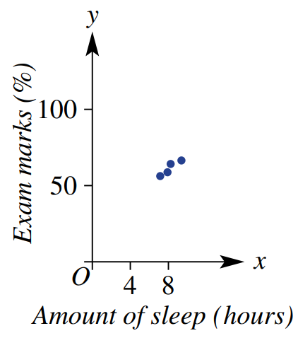
- A person presents you with this scatter plot and suggests a strong correlation between the amount of sleep and exam marks.
What might be a problem with the person’s graph and conclusions?

The axis is not appropriate, the distances between points is likely larger.
There are only 4 data points. It is not enough to make a conclusion.

- 2012 HSC Standard 2 Band 4
Which of the following relationships would most likely show a negative correlation?
(A) The population of a town and the number of hospitals in that town.
(B) The hours spent training for a race and the time taken to complete the race.
(C) The price per litre of petrol and the number of people riding bicycles to work.
(D) The number of pets per household and the number of computers per household.
B

Interpolation and Extrapolation

- Interpolation and Extrapolation
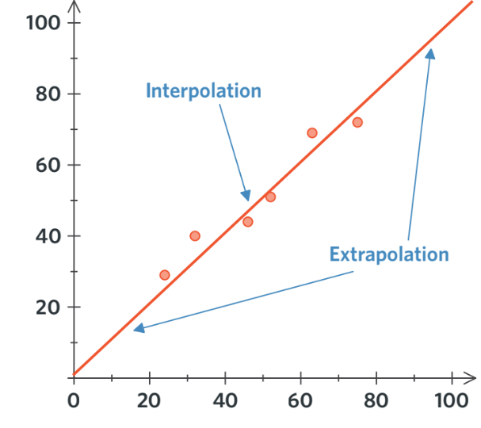
- We use a line of best fit to predict data values.
- Interpolation predicts values within existing data.
- Extrapolation predicts values outside existing data.
- Interpolation is more accurate than extrapolation;
the relationship may change beyond known data.

- Example Interpolate and extrapolate data using a line of best fit
The scatterplot shows the length of the forearm-and-hand against the length of the forearm.
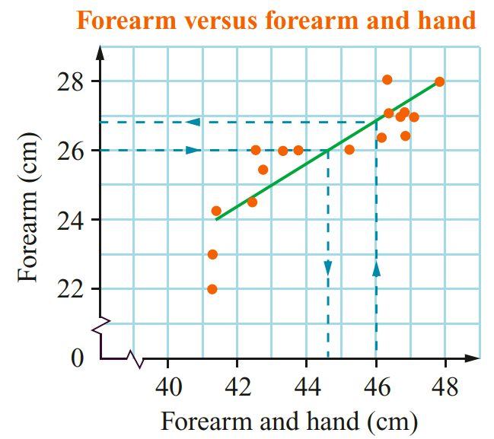
Use the given line of best fit to predict:

The forearm measurement for a student with
a forearm-and-hand measurement of 46 cm.

Around $26.8$ cm
The forearm-and-hand measurement for a
student with a forearm measurement of 26 cm.

Around 44.6 cm

- Guided Practice
This scatterplot shows the heights and armspans of a group of students.
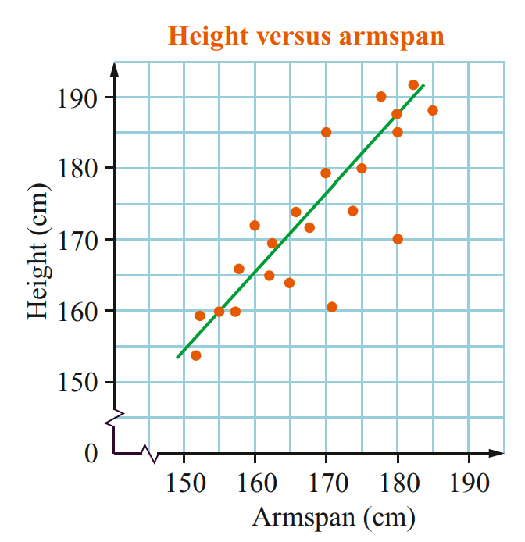
Use the given line of best fit to predict:
The height of a student with 175 cm armspan.

Around 182 cm
The armspan of a student with 185 cm height.

Around 178 cm
Why would it not make sense to extend the line?

There are no data points beyond the current line of best fit.

Foundation
- This scatterplot shows the height and lung capacity of a group of students.
A line of best fit has been drawn for these points.
Use the line of best fit to predict:
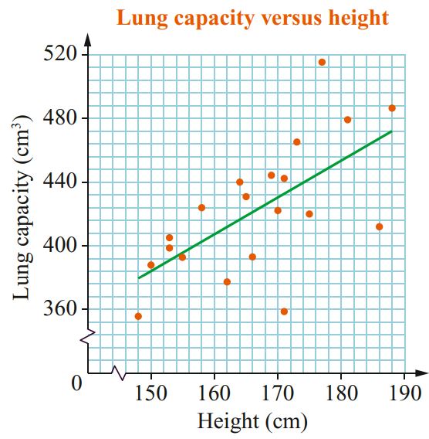
  - The lung capacity of a student with a height of:
    - 160 cm ……………………………
408 cm³
    - 178 cm ……………………………
448 cm³
  - The height of a student with a lung capacity of
    - 400 cm³ ……………………………
157 cm
    - 420 cm³ ……………………………
166 cm

- This scatterplot shows the age and value for a sample of cars of a particular model.
A line of best fit has been drawn for these points. Use the line to predict:
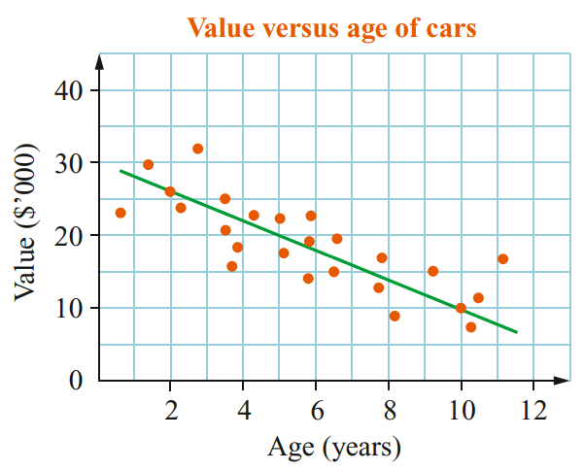
  - the value of a car of this model of age
    - 10 years ……………………………
$10 000
    - 5 years ……………………………
$20 000
  - the age of a car of this model with a value of
    - $15 000 ……………………………
7.5 years
    - $25 000 ……………………………
2.5 years
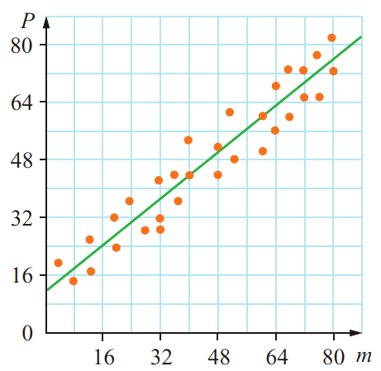
- Use the graph to estimate:
  - the value of $P$ when $m=80$.

75
  - the value of $m$ when $P=50$.

48

Development
- The scatterplot opposite shows the rainfall (in mm) and the percentage of clear days for each month in a year. Each dot represents a month.
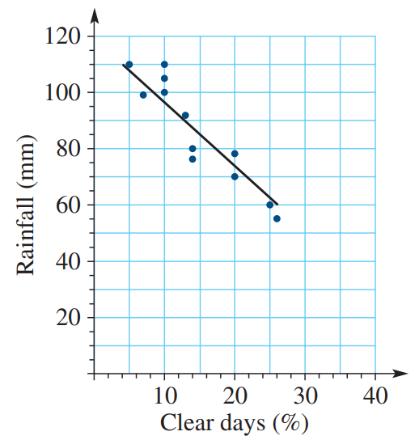
  - How many months had exactly 10% of clear days?
3
  - What was the percentage of clear days for the month where rainfall was 70mm?
20%
  - Describe the strength of the relationship as strong, moderate, or weak.
strong
  - Use the line of best fit to predict the rainfall in the month given the following percentage of clear days:
    - 15% ……………………………
85%
    - 22% ……………………………
70%
  - Predict the percentage of clear days in the month given the following rainfall:
    - 80 mm ……………………………
17%
    - 90 mm ……………………………
12.5%

- The scatterplot shows a mother’s height and her daughter’s height.
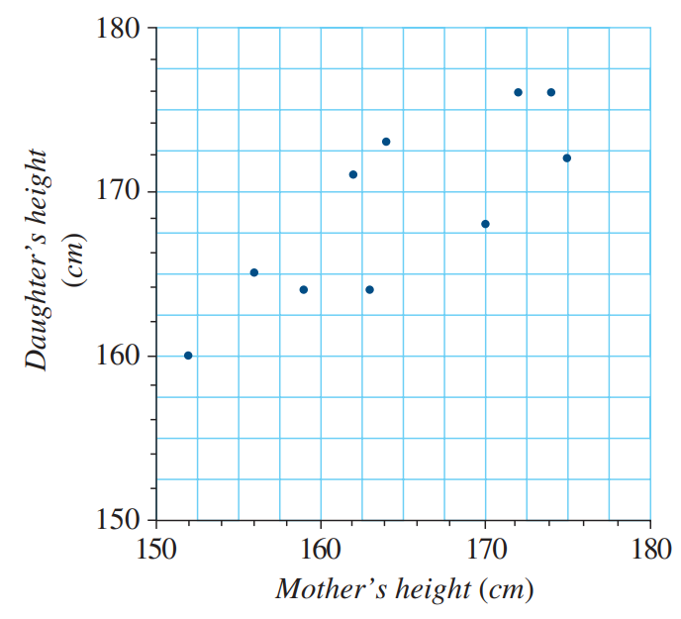
  - Draw a line of best fit.
  - Describe the strength of the relationship as strong, moderate, or weak.
Moderate
  - Estimate the daughter’s height if the mother’s height is 170 cm.
172 cm
  - Estimate the mother’s height if the daughter’s height is 162 cm.
154 cm

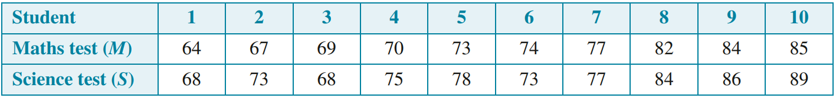
- The results of a group of students on Mathematics and Science tests are compared.

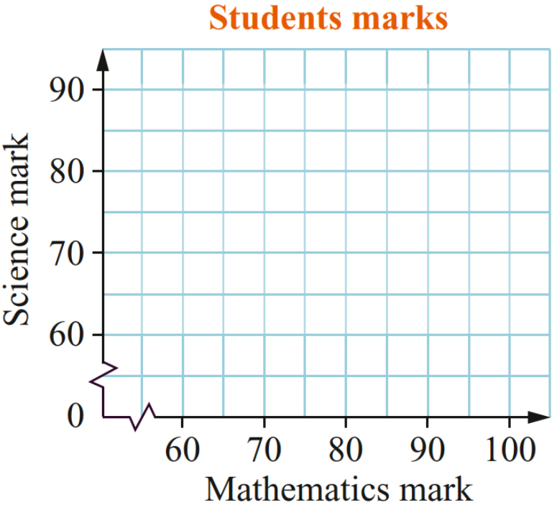
  - Show these results as a scatterplot.
  - Describe the strength of the relationship as strong,
moderate, or weak.
strong
  - Use a line of best fit to estimate the score in Science of a student who scores 80 in Mathematics.
82
  - Use the line of best fit to estimate the score in Mathematics of a student who scores 60 in Science.
56
  - Is part c or part d an example of extrapolation?
d as it is outside the range of existing data.
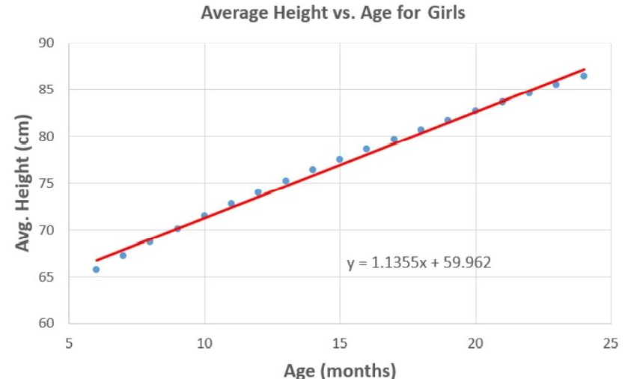
- April collects data on the average height vs age for baby girls.
Explain why this line of best fit is not useful for predicting the age of 30-year-old women.

Baby girl height growth might be linear, but this trend is unlikely to continue for until a woman is 30.
- The scatter graph shows the cost of rent per month for office space and the distance from the city centre.
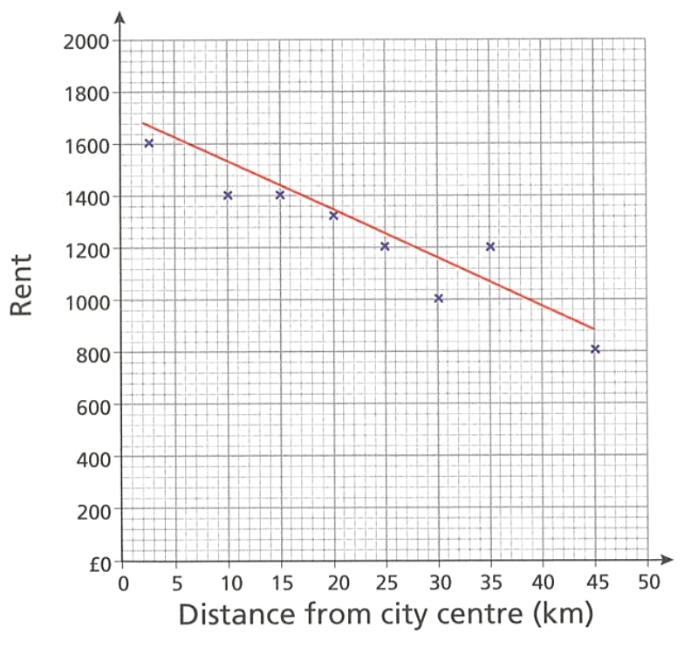
  - What is the direction of correlation shown in the scatter graph?
negative
  - Estimate the distance from the city centre for an office space that costs $1000 per month.
38 km
  - If the graph was extended to up to 100 km from the city centre, do you think the trend shown by the line of best fit would continue? Explain your answer.

No. The trend is unlikely to continue so far outside the existing range of data.

- Experiments were run in a greenhouse to determine the effect of temperature on berry production. Sections of the greenhouse were kept at different temperatures and the mass of berries produced was then measured (the yield). The gathered data is shown in the scatterplot, along with the line of best fit.
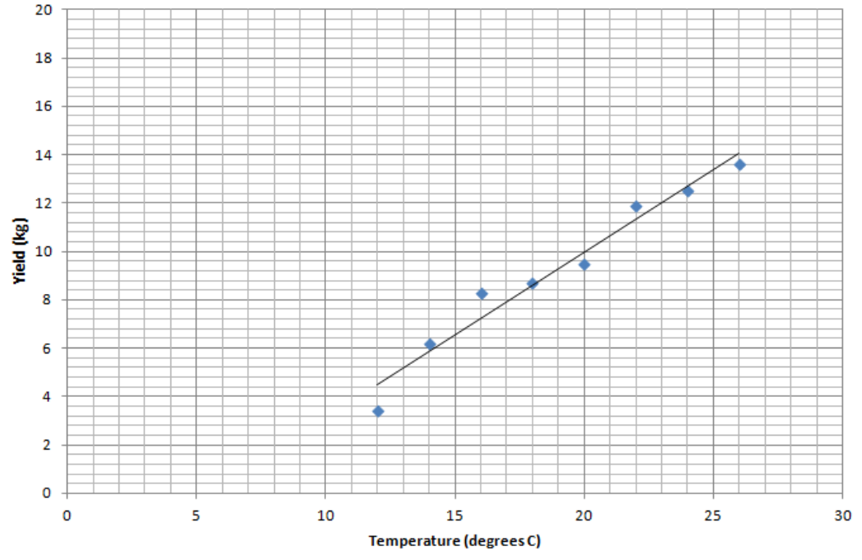

  - Use the line of best fit to estimate the yield for plants kept at 19°C.
9.2 kg
  - Extend the line of best fit to extrapolate the temperature required for a yield of 16 kg.
28.5$°$C
  - Extrapolate to determine the approximate temperature at which the bushes would produce no berries. How might the lowest data point affect your answer?

5.5$°$C. The lowest datapoint could suggest that the relationship may not be linear at very low temperatures, affecting the accuracy.
  - Would it be sensible to extrapolate to determine the yield for a temperature of 50°? Why?

No. Predictions beyond the existing range may not follow the same trend. Heat stress could cause the yield to drop rapidly.
- The plot shows the density of the rabbit population per square kilometre mapped against altitude in a region.
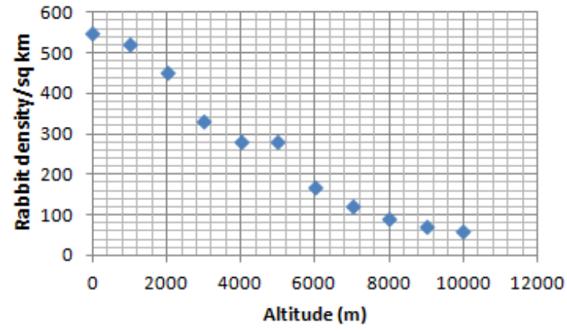
  - An altitude of 0 m indicates sea level. What does your line of best fit imply will happen to the density of the rabbit population if the land were to dip below sea level?

The line of best fit would suggest that the rabbit population would be high, which is not accurate.
  - Where does your line of best fit intersect the horizontal axis and what does this imply?

The population should be zero at around 10 000 m, which is not true.
  - By observing the flow of the data points, what can you suggest is the true trend at higher altitudes?
The association is likely non-linear, there won’t be many rabbits, but they could still survive at higher altitudes.

Mastery
- 2020 HSC Standard 1
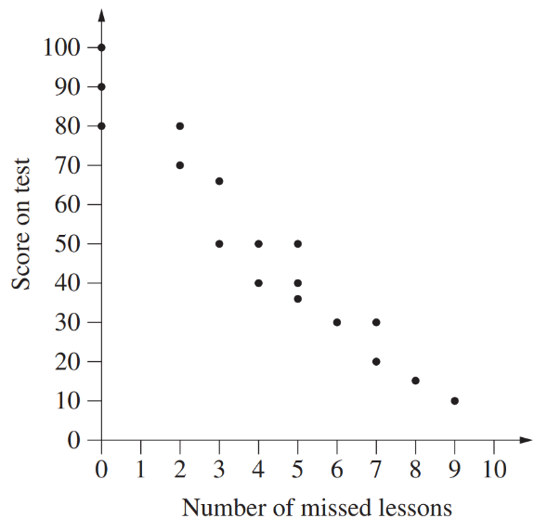
A group of students sat a test at the end of term. The number of lessons each student missed during the term and their score on the test are shown on the scatterplot.
Describe the strength and direction of the linear association observed in this dataset.

Strong negative
Calculate the range of the test scores for the students who missed no lessons.

100 – 80 = 20
Draw a line of best fit on the scatterplot.
Meg did not sit the test. She missed five lessons. Use the line of best fit drawn to estimate Meg’s score on this test.

Between 41 and 46 (depends on your line of best fit)
John also did not sit the test and he missed 16 lessons. Is it appropriate to use the line of best fit to estimate his score on the test? Briefly explain your answer.

No. Extrapolation beyond the range of data is usually inappropriate.
- 2022 HSC Standard 1
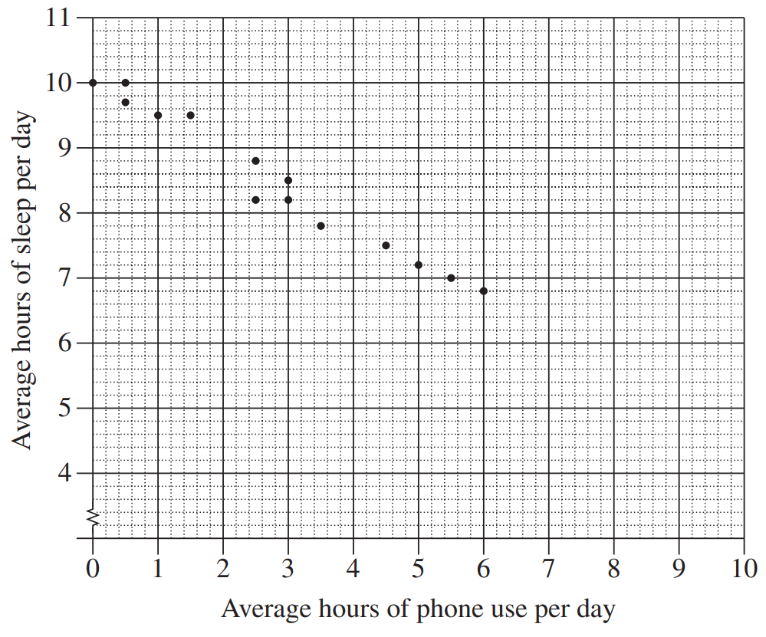
A teacher surveyed the students in her Year 8 class to investigate the relationship between the average number of hours of phone use per day and the average number of hours of sleep per day. The results are shown on the scatterplot below.
The data for two new students, Alinta and Birrani, are shown in the table below.
Plot their results on the scatterplot.
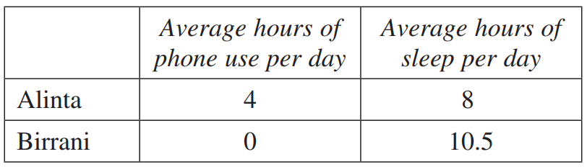

By first fitting the line of best fit by eye on the scatterplot, estimate the average number of hours of sleep per day for a student who uses the phone for an average of 2 hours per day.

Around 9 hours.

Equation of a Line of Best Fit

- Review
- Identify gradient and $y$-intercept in a linear equation
- $y=3x+4$  $m=$  $c=$ | - $y=8x-2$  $m=$  $c=$ | - $y=0.2x+5$  $m=$  $c=$ | - $y=9+3x$  $m=$  $c=$
- $y=-8+3x$  $m=$  $c=$ | - $y=7-2x$  $m=$  $c=$ | - $y=x-5.52$  $m=$  $c=$ | - $y=-55.68x$  $m=$  $c=$

- Interpret linear models
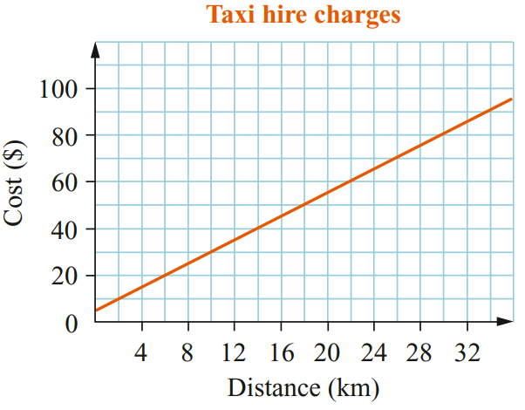
  - From the graph, find the cost of travelling 22 km.

  - How far can a passenger travel for $30?

  - Find the $y$-intercept.
What is its meaning in this situation?

  - Identify the gradient. What is its meaning in this situation?

  - Write and equation relating cost $C$ and distance $d$

- Equation of a Line of Best Fit
The equation of a line of best fit is also called a regression equation, if it was determined using a special method using a calculator.
Rate of change; $m$ per $x$
Initial or fixed value at $x=0$
Dependent variable
Independent variable
$$y=mx+c$$

- Example Interpret the intercept and gradient of a line of best fit
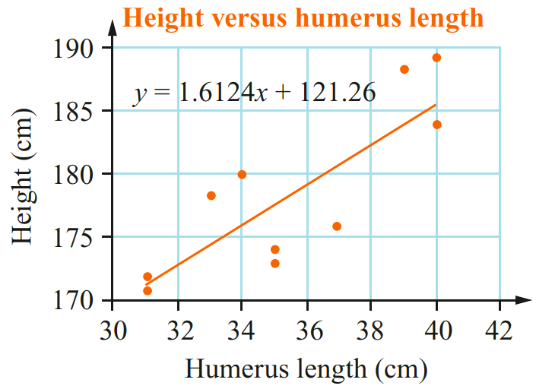
A spreadsheet calculated the equation of the line of best fit.
Interpret the meaning of the gradient.
Height increases by 1.6124 cm
per 1 cm increase in humerus length.

Interpret the meaning of the $y$-intercept.
When humerus length is 0,
height is likely $121.26$ cm.

Does the $y$-intercept make sense in this scenario?
This does not make sense as the length of a humerus will never be 0.

- Guided Practice
The scatterplot shows the heights (in cm) and masses (in kg) of 9 people.
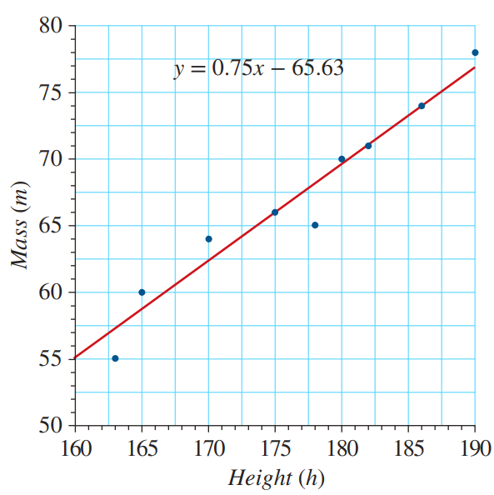
Interpret the meaning of the gradient.

………………… increases by ……………
per ……… increase in ………………………
Interpret the meaning of the $y$-intercept.
When ………………… is 0,
………………… would be $-65.63$ kg.

Does the $y$-intercept make sense in this scenario?

Foundation

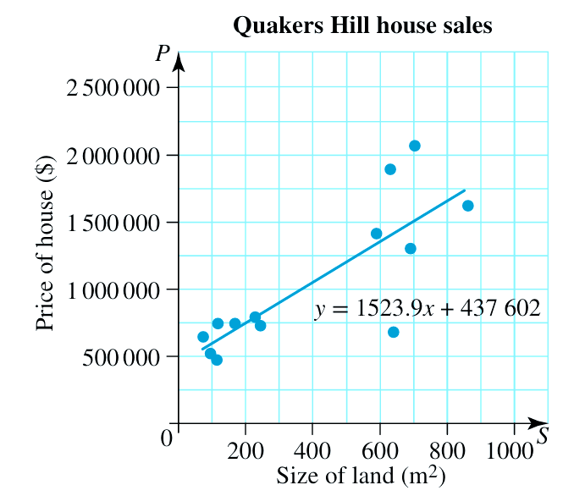
  - What is the independent variable?
Size of land (m²)
  - What is the dependent variable?
Price of house ($)
  - What is the gradient?
1523.9
  - What does it represent?
………………… increases by …………
per ……… increase in ……………
House price increases by $1523.90 per 1 m² increase in land.
  - What is the $y$-intercept?
437 602
  - What does it represent?
When ………………… is 0, ………………… would be ………
When land size is 0, house price would be $437 602
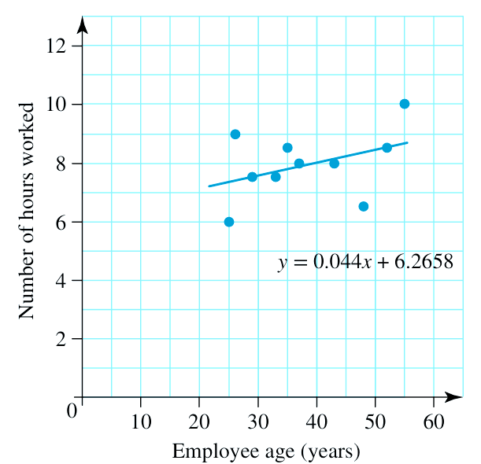
  - What is the gradient?
0.044
  - What does it represent?

Hours worked increases by 0.044 hours per 1 year increase in employee age.
  - What is the $y$-intercept?
6.2658
  - What does it represent?

An employee who is 0 years old would work 6.2658 hours.
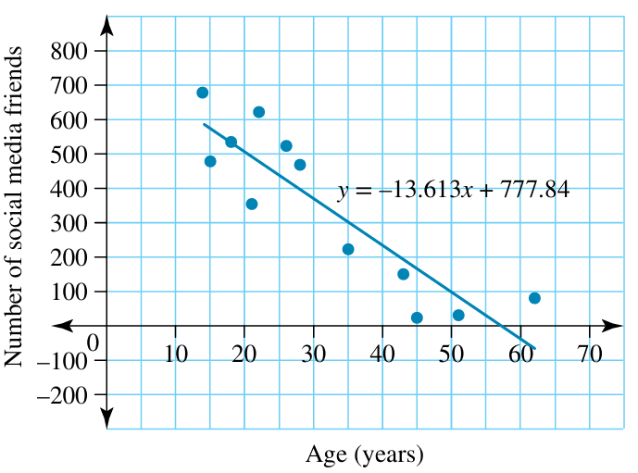
  - Interpret the meaning of the gradient.

Number of social media friends decreases by 13.613 per year of age.
  - Interpret the meaning of the $y$-intercept.

A person who is 0 years old would have 777.84 social media friends.

Interpolating and Extrapolating using the Equation

- Interpolating and Extrapolating using the Equation
We can use the equation of the line to interpolate and extrapolate without using the line itself.
- Identify the given variable: independent ($x$) or dependent ($y$).
- Substitute the known value into the equation.
- Solve to find the unknown variable.

- Example Interpolate and extrapolate using the linear regression equation
The equation of a line of best fit is given by $y=1.6x+121$.
The independent variable $x$ is humerus length (cm).
The dependent variable $y$ is height (cm).

Predict the height of a student with humerus length of 20 cm  1. $Let x=20$  2. $y=1.6\left(40\right)+120$  3. $=185 cm$ | Predict the humerus length of a student with a height of 165 cm  1. Let $y=165$  2. $165=1.6x+121$  3. $165-121=1.6x$  $\frac{165-121}{1.6}$ $=x$  $27.5 cm=x$

- Guided Practice
The equation of a line of best fit is given by $y=1.2x-36$,
where the independent variable $x$ is armspan and the dependent variable $y$ is height.
- Calculate the height of a student with armspan of length 178 cm.  Let ……… $=178$  177.6 cm | - Calculate the armspan length of someone with height 163 cm.  Let ……… $=163$  165.8 cm

Foundation
- A brand of medication for babies bases the dosage on the age (in months) of the child.
The regression equation for this situation is $M=0.312A+0.157$, where $M$ is the amount of medication in mL and $A$ is the age in months.
  - Identify the independent variable and dependent variable.
Independent: age in months | Dependent: amount of medication in mL
  - Calculate the amount of medication required for a child aged 6 months.
Let …… $=6$

2.029 mL
  - Determine the age of a child who requires 2.5 mL of the medication.
Give your answer correct to 1 decimal place.
Let …… $=2.5$

7.5 months
- A survey of the nightly room rate for Sydney hotels and their proximity to the Sydney Harbour Bridge produced the regression equation $C=-50.471d+281.92$, where $C$ is the cost of a room per night in dollars and $d$ is the distance to the bridge in kilometres.
  - Calculate the cost of a hotel room 2.5 km from the bridge.
Give your answer correct to the nearest cent.

$155.74
  - Determine the distance of a hotel room from the bridge if the cost of the room was $115. Give your answer correct to 2 decimal places

3.31 km
- The equation of the line of best fit connecting hip measurement ($H$), in cm, and waist measurement ($W$), in cm, is $W=0.7H-2.1$. Use the equation to predict:
- The waist of a person with a hip measurement of 96 cm.  65.1 cm | - The hip measurement of a person with a waist of 65 cm.  95.86 cm

- The equation of the line of best fit connecting grape yield ($G$), in tonnes, of a vineyard and the number of frosts ($n$) during the growing season is $G=-0.14n+5.6$. Predict:
- The yield when there are 5 frosts.  4.9 t | - The yield when there are 12 frosts.  3.92 t | - The most number of frosts if you want the yield to be at least 3.5 t.  15 frosts

- Talula was investigating the relationship between the number of weeks ($n$) people have been on a new diet and their overall weight loss in pounds ($w$).
She determines the line of best fit for the relationship as $w=3.5+1.1n$.
  - Talula says the gradient is $3.5$ and $y$-intercept is $1.1$. Explain why she is incorrect.
The gradient is 1.1 and $y$-intercept is 3.5.
  - Interpret the gradient of the line of best fit in the context of the data.
1.1 pound weight loss per week.
3.5 pound weight loss at 0 weeks!
  - Does it make sense to interpret the vertical intercept in the context of the data?
No, you won’t lose weight just by signing up.
- Answer the following questions for the equation $I=0.43+1.1s$
where $I$ is the number of insects caught and $s$ is the area of a spider’s web in cm².
  - Interpret the meaning of the gradient.
1.1 increase in insects caught per 1 cm² increase in web area.
  - Interpret the meaning of the $y$-intercept.
0.43 insects caught when web area is 0 cm²
  - Does the $y$-intercept make sense?
No, a web area of 0 won’t catch any insects.
  - Is the trendline of the data positive or negative?
Positive.
  - Determine how many insects are likely to be caught if the area of the web is 60 cm².
Give your answer correct to the nearest whole number.
66 insects

Development
- In the scatterplot shown, the line of best fit has the equation of $c = 13.33+2.097m$,
where $c$ is the number of new customers each hour and $m$ is the number of market stalls.
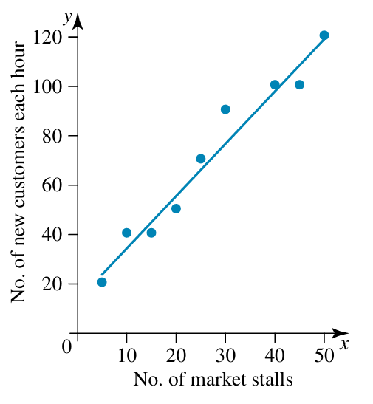
  - Using the line of best fit,
find the number of new customers expected
if there are 30 market stalls.

76 new customers per hour.
  - Use the equation to find the number of market stalls required to expect 150 new customers.

65 stalls
  - Explain why part a is interpolation, while part b is extrapolation.

30 market stalls $\left(x\right)$ is within the existing range of data. 150 new customers $\left(y\right)$ is not.
- 2023 HSC Standard 1
The scatterplot shows the number of ice-creams sold, $y$, at a shop over a ten-day period, and the temperature recorded at 2 pm on each of these days.
The data are modelled by the equation of the line of best fit given below:
$y = 0.936x-8.929$, where $x$ is the temperature.
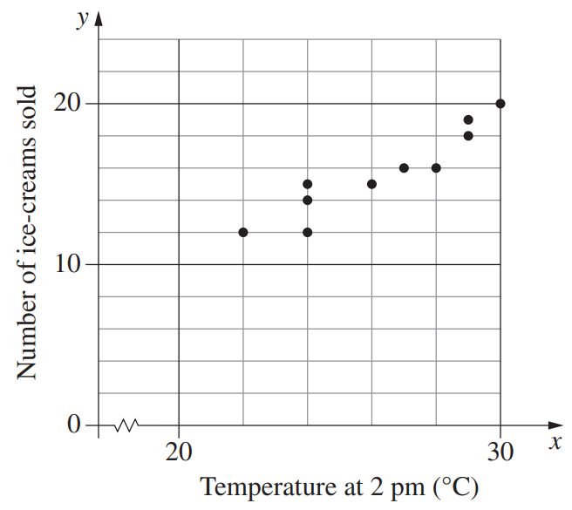
Sam used a particular temperature with this equation and predicted that 23 ice-creams would be sold.
What was the temperature used by Sam, to the nearest degree?

34 degrees.
In using the equation to make the prediction in part (a), was Sam interpolating or extrapolating?
Justify your answer.

Extrapolating, as 23 ice creams is not within the existing range of data.

Mastery
- 2013 HSC Standard 2 Band 5
Ahmed collected data on the age ($a$) and height ($h$) of males aged 11 to 16 years.
He created a scatterplot of the data and constructed a line of best fit to model the relationship between the age and height of males.
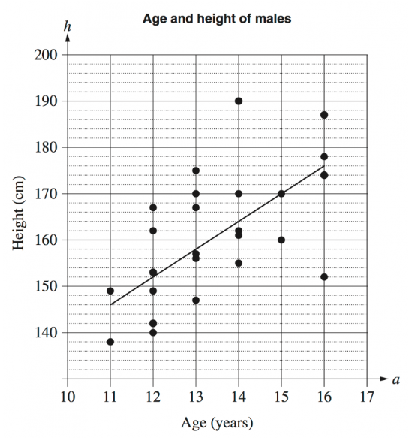
Determine the gradient of the line of best fit.

6
Explain the meaning of the gradient of the line of best fit.

Males should grow 6 cm per year between ages of 11 to 16
Determine the equation of the line of best fit.

$$h=6a+80$$
Use the equation to predict the height of a 17-year-old.

182 cm
Why would this model not be useful for predicting the height of a 45-year-old male?

People eventually stop growing when they become adults. The height vs age trend is not always linear.
- This scatter plot shows a linear relationship between Mathematics marks and Physics marks in a small class of students. A trend line passes through (20, 30) and (70, 60).
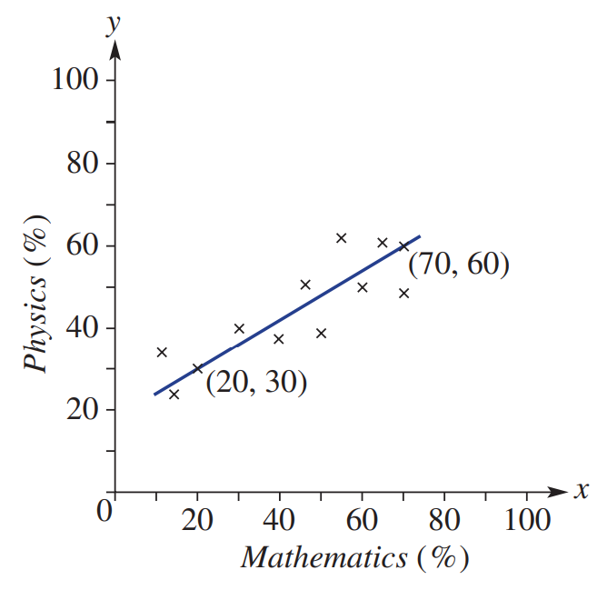
  - Find the equation of the line if the $y$-intercept is $18$.

$$y=0.6x+18$$
  - Use your equation to find the Physics score
if the Mathematics score is:
    - 40
42
    - 90
72
  - Use your equation to find the Mathematics score if the Physics score is:
    - 36
30
    - 78
100

Pearson’s $r$ value

- Pearson’s Correlation Coefficient
Pearson’s correlation coefficient ($r$) precisely measures association strength.
- $r$ ranges from $-1$ to $1$.
- In stronger relationships, data points are closer to the line of best fit, yielding more accurate predictions.
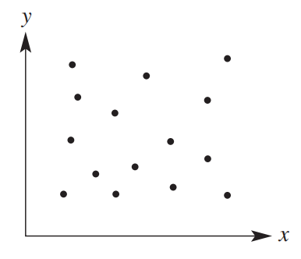
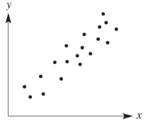
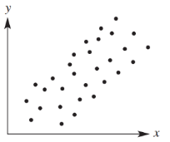
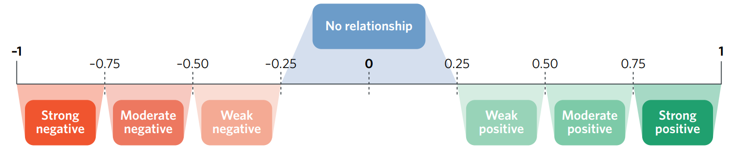
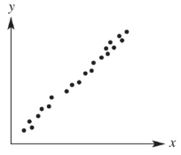
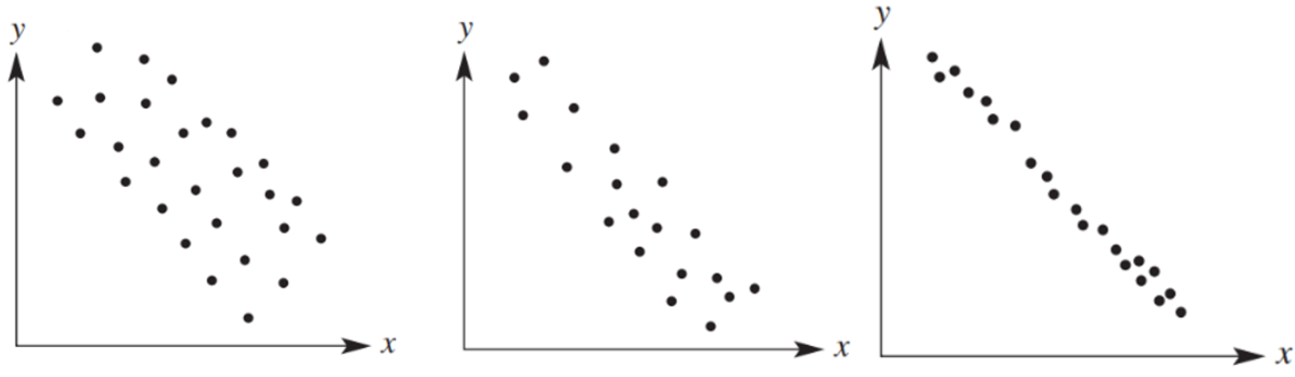

- Example Interpret Pearson’s $r$ value
The members of a sporting club are training to increase thigh circumference.
Each fortnight, the thigh circumference of each member is measured.
At the conclusion of the training period, the correlation coefficient comparing thigh circumference with time is 0.73.
What can you conclude about the relationship between thigh circumference and time?
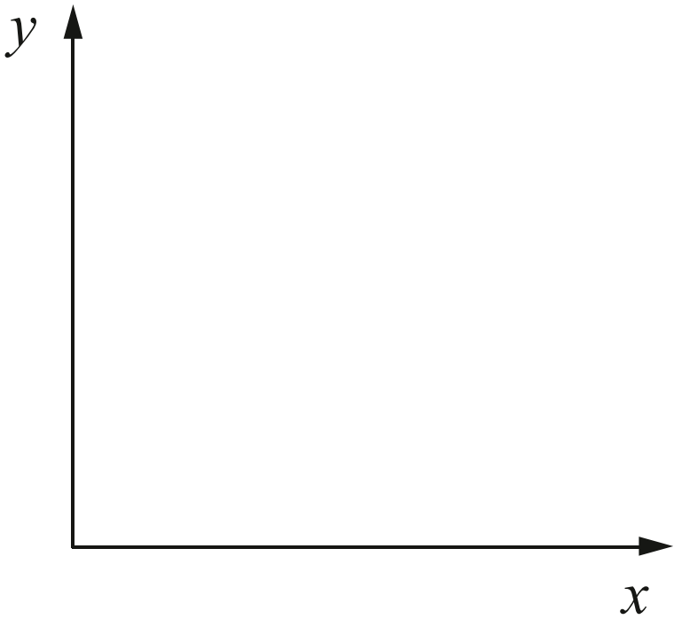
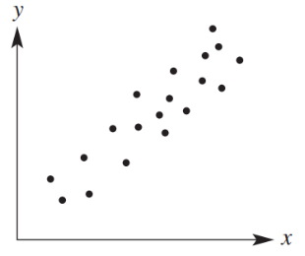
There is a moderate, positive correlation between weight training and thigh circumference

- Guided Practice
Scientists are trying to find a method of reducing knee pain.
The correlation between quadricep strength and knee pain is $-0.83$.

Draw what the scatterplot might look like.
What can you conclude about the relationship between quadricep strength and knee pain?

Stronger quadriceps generally lead to less knee pain.

Foundation
- 2020 HSC Standard 2 Band 4
For a set of bivariate data, Pearson's correlation coefficient is –1.
Which graph could best represent this set of bivariate data?
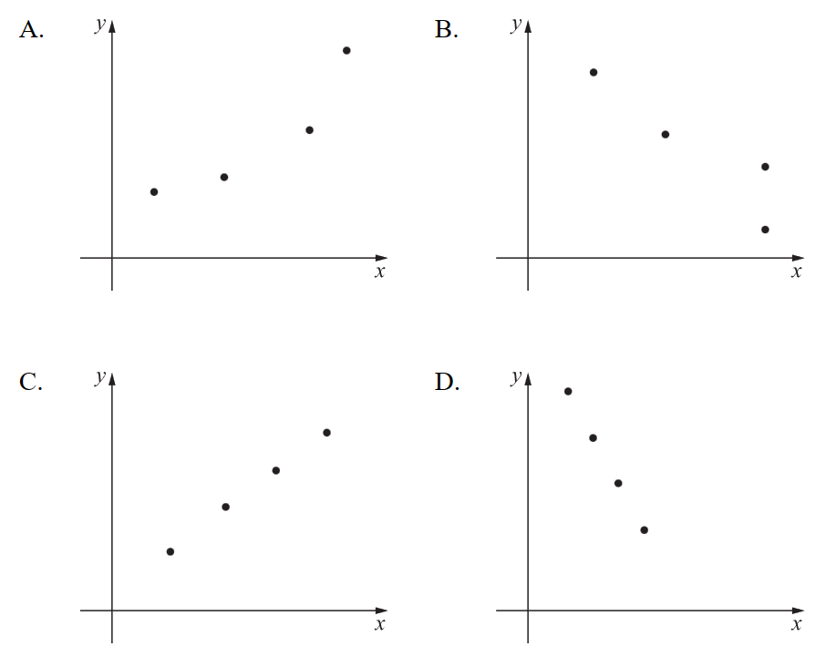

D
- 2013 HSC Standard 2 Band 4
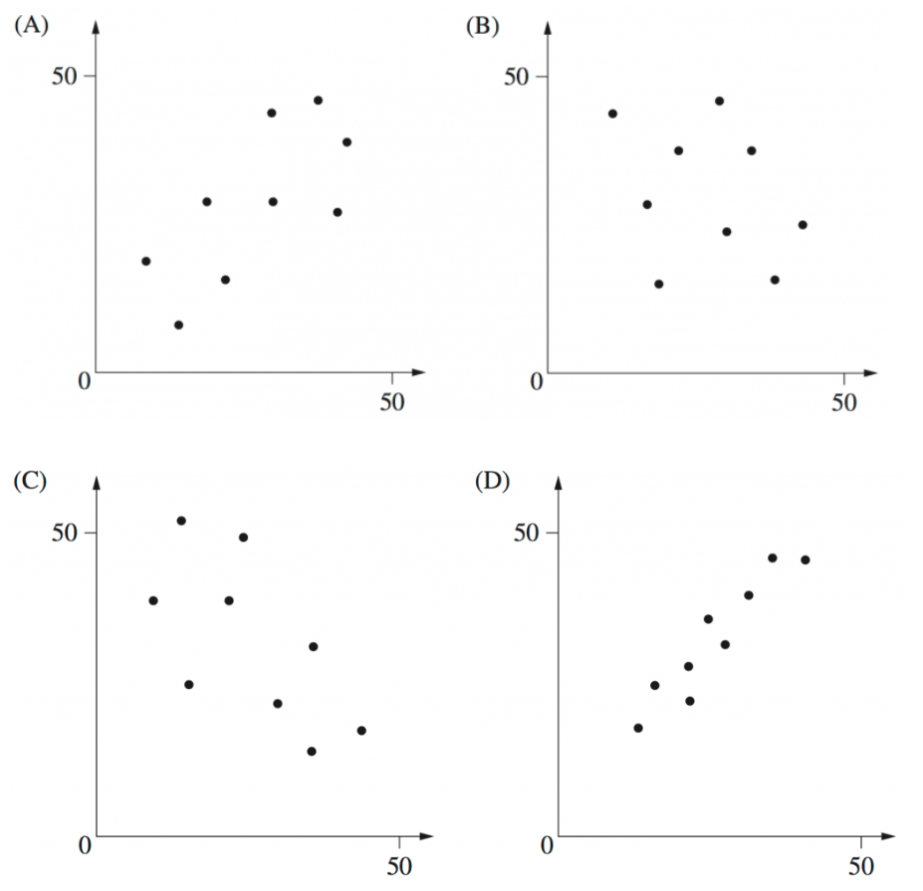
Which graph best shows data with a correlation closest to 0.3?

A
- 2016 HSC Standard 2 Band 4
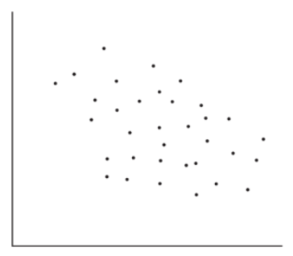
The graph shows a scatterplot for a set of data.
Which of the following is the best approximation for the correlation coefficient of this set of data?
(A) $-1$
(B) $-0.3$
(C) $0.3$
(D) $1$

B
- 2008 HSC Standard 2 Band 4
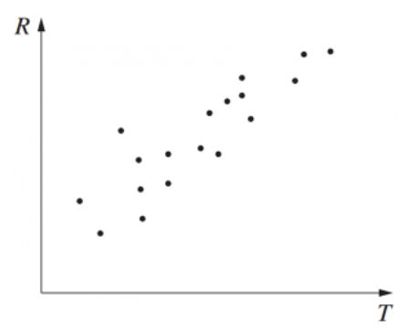
A scatterplot is shown. Which of the following best describes the correlation between $R$ and $T$?

(A) Positive
(B) Negative
(C) Positively skewed
(D) Negatively skewed
A

- 2011 HSC Standard 2 Band 4
In which graph would the data have a correlation coefficient closest to –0.9?
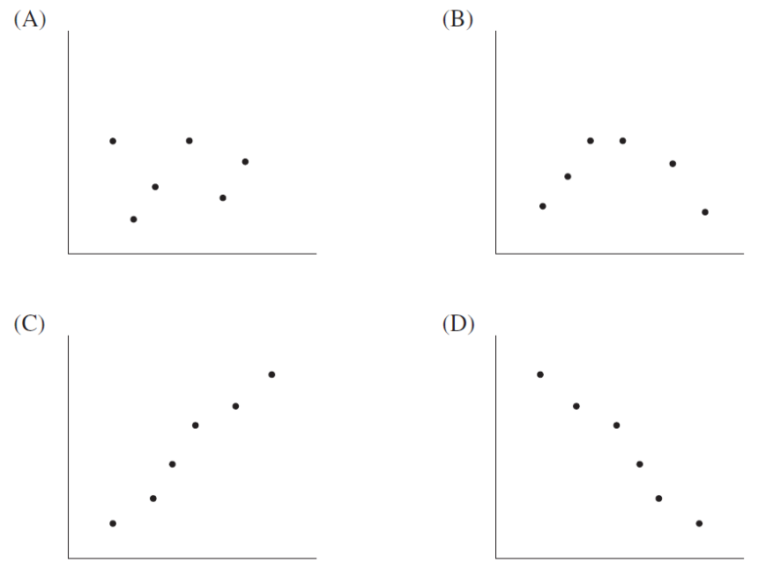

D
- A gym is using a new training program to increase bicep circumference.
Each fortnight the bicep circumference of each person is measured.
At the end of the program, the bicep measurements are compared with time.
The correlation coefficient is 0.64. What does this mean?

The relationship between time in the training program and bicep circumference is moderate and positive.
- Ten people are on a 6-week diet to lose weight. Their weight is recorded every week.
The correlation coefficient of the data is −0.77. Does this show that the diet works?

Yes. There is a strong negative correlation between time in the diet and weight (weight decreases with time).
- The correlation coefficient for a student’s Mathematics performance in Year 10 vs Year 12 was found to be 0.23. What can you say about this relationship?

There is no relationship.
- The line of best fit comparing salary, in thousands, at age 35 $\left(S\right)$ and number of years of study $\left(n\right)$ is given by $S=3.5n+9.8$.
  - Predict the salary of someone who has completed:
- 10 years of study  (left school year 10)  $44 800 | - 12 years of study  (no university)  $51 800 | - 17 years of study  (double degree)  $69 300

  - The value of Pearson’s correlation coefficient is $r=0.6$.
How accurate do you expect these predictions to be?

Moderately accurate.

Development
- HSC Sample Question Band 3
A student claimed that as time spent swimming training increases, the time to run a 1-kilometre time trial decreases.
After analysing the data, the student found the correlation coefficient, $r$ to be – 0.73.
What does this correlation indicate about the relationship between the time a student spends swimming training and their 1 kilometre run time trial times.

As time spent training swimming increases, 1 km run time decreases.
There is a moderate negative correlation.
- For three months, Cameron has been wearing an exercise tracking wristband that records the distance he walks and the number of calories he burns. The graph shows his weekly totals. The regression line equation for this data is $y=14301+115.02x$.
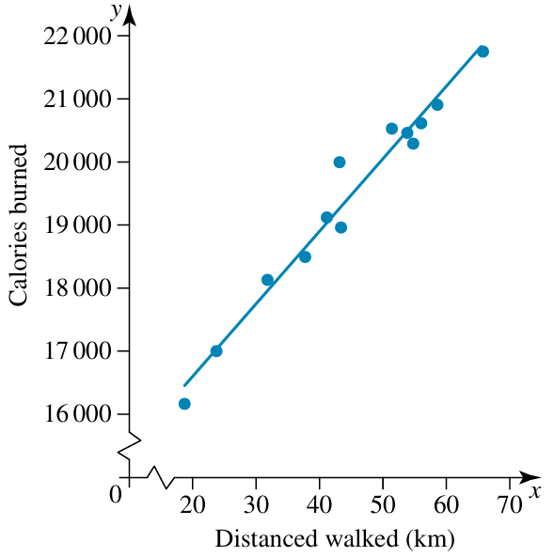
  - Using the equation for the regression line, determine the number of calories burned if a person walked 50 km in a week.

20052 calories
  - Is this interpolation or extrapolation?
Interpolation

  - Due to an injury, in one week Cameron only walked 10 km and he forgot to wear his tracker. Determine the number of calories this distance would burn.

15451.2 calories
  - Is this interpolation or extrapolation?

Extrapolation
  - Pearson’s correlation coefficient for this data is 0.9678.
What does this mean for the direction and strength of the correlation?

Strong positive

Mastery
- 2015 HSC Standard 2 Band 5
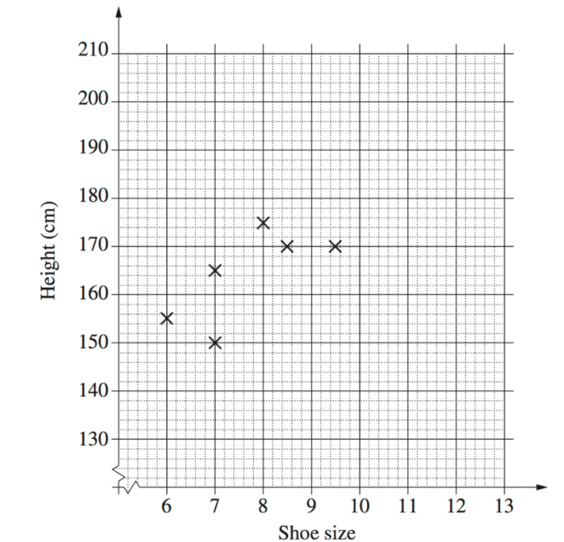
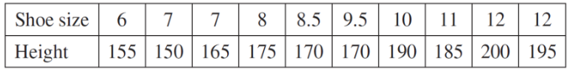
The shoe size and height of ten students were recorded.

Complete the scatter plot and draw a line of fit by eye.
Use the line of fit to estimate the height difference between a student who wears a size 7.5 shoe and one who wears a size 9 shoe.

Around 13 cm
A student calculated the correlation coefficient to be 1 for this set of data. Explain why this cannot be correct.

A correlation coefficient of 1 means all data points would lie perfectly on the line of best fit, which is not the case.

- 2021 HSC Standard 2 Band 5
A salesperson is interested in the relationship between the number of bottles of lemonade sold per day and the number of hours of sunshine on the day.
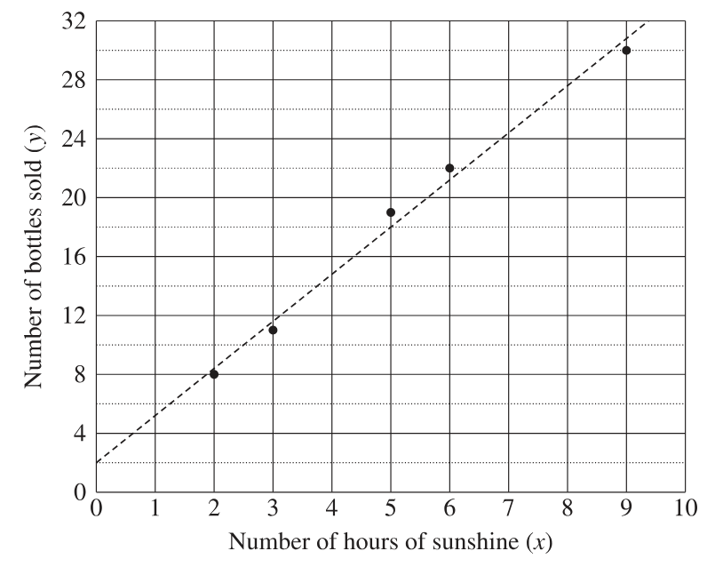
The diagram shows the dataset used in the investigation and the least-squares regression line.
What is the equation of the least-squares regression line relating to the dataset?

$$y=3.2x+2$$

Suppose a sixth dataset was collected on a day that had 10 hours of sunshine and 45 bottles of lemonade sold. What would happen to the gradient of the line?

The gradient would increase (steepen)

- 2014 HSC Standard 2 Band 6
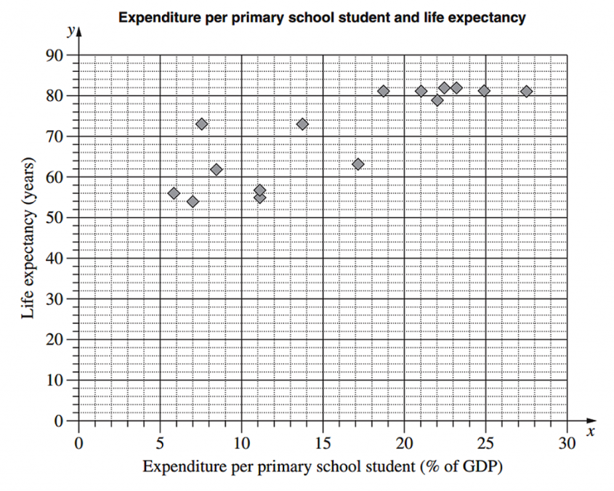
The scatterplot shows the relationship between expenditure per primary school student, as a percentage of a country’s Gross Domestic Product (GDP), and the life expectancy in years for 15 countries.

For the given data, the correlation coefficient, $r$, is 0.83. What does this indicate about the relationship between expenditure per primary school student and life expectancy for the 15 countries?

There is a strong positive correlation between expenditure per primary student and life expectancy.
For the data representing expenditure per primary school student, $Q_{L}=8.4$ and $Q_{U}=22.5$. Calculate the interquartile range.

14.1
Another country has an expenditure per primary school student of 47.6% of its GDP.
Would this country be an outlier for this set of data? Justify your answer with calculations.

Yes, the upper limit for being an outlier is 43.65%
On the scatterplot, draw the least-squares line of best fit $y=1.29x+49.9$
Using this line, estimate the life expectancy in a country which has an expenditure per primary school student of 18% of its GDP.

Around 73 years.
Why is this line NOT useful for predicting life expectancy in a country which has expenditure per primary school student of 60% of its GDP?

60% GDP is far outside the existing range of data.
- The scatterplot compares examination mark to a student’s self-reported motivation score.
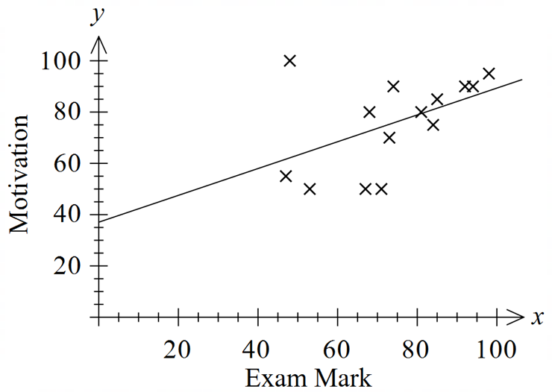

  - Identify which student is most likely to be considered the outlier. Circle the data point.

(45, 100)
  - Pearson’s correlation coefficient $r$ is $r=0.48$.
Describe the strength of the relationship between exam mark and motivation.

Weak positive.
  - The equation of the line of best fit is $y=0.52x+37.1$.
Predict the motivation score of a student who scored 86.

81.82
  - Would the linear regression model be useful for predicting the motivation of a student who scored 20 in the exam?

No. It is far outside the existing range of data.
  - With the outlier removed, the new equation of the line of best fit is $y=mx+4.1$.
Describe how $m$ would change.

$m$ would become more positive as the gradient of the line of best fit would become more positive, steeper.
  - Would removing the outlier increase or decrease Pearson’s correlation coefficient $r$?
Give a brief explanation for your answer.

Increase. On average, the datapoints would now be closer to the line of best fit,

Bivariate Data Analysis using a Calculator

- Regression Equation on a Calculator
Gradient
rate of change;
$m$ per $x$
$y$-intercept
$y$ value at $x=0$
$$y=a+bx$$


CASIO FX-82 AU
1. Set calculator Statistics Mode 2-var:
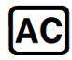
2. Enter your data into the table using numbers, arrows and equals button.
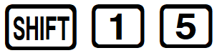
3. Press to save the data.
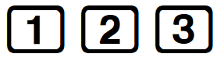
Calculate regression statistics: Note: regression line is $y=A+Bx$
$r$ Pearson’s $r$
$A$ $y$-intercept

$B$ Gradient
Then press

CASIO FX-8200 AU
1. Press HOME

2. Select

3. Select [2-Variable]
4. Enter data using the arrow keys and
5. After entering your data, press [Reg Results]
6. Press [y=a+bx] for linear analysis
$a$: $y$-intercept
$b$: Gradient
$r$: Pearson’s $r$

- Example Calculate regression statistics using a calculator
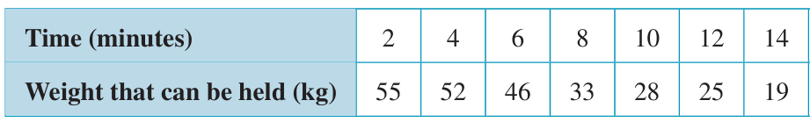
Find the equation of the regression line and Pearson’s $r$ value to 2 d.p. for this set of data.

$y=62.57-3.21x$ with $r=-0.98$

Foundation
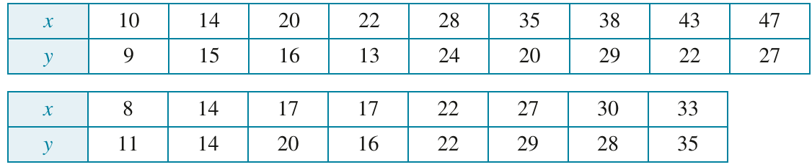
- Find Pearson’s $r$ and equation of the line of best fit $y=a+bx$ for the tables below.

- Pearson’s correlation coefficient $r$  0.98 | - Strength and direction  Strong positive | - Equation of the line of best fit $y=a+bx$  $$y=2.06+0.94x$$

- Pearson’s correlation coefficient $r$  0.86 | - Strength and direction  Strong positive | - Equation of the line of best fit $y=a+bx$  $$y=6.82+0.44x$$

- The time $t$ it takes a number of students to swim 25 m freestyle is recorded in the table.

- Pearson’s correlation coefficient $r$  $$=-0.26$$ | - The equation of the line of best fit  $$y=a+bx$$  $$y=30.35-0.23x$$
Identify the strength and direction of the association.
Negative weak
Interpret the gradient and $y$-intercept
Time taken to swim 25 m decreases by 0.23 of a second each year of age
At age 0 years, it would take 30.35 seconds to swim 25 m
- The results of group of students on Mathematics and Science tests are compared.

  - Find the equation of the regression line.
$$S=8+0.93x$$
  - Predict the score in Science of a student who scores 80 in Mathematics.
82.4
  - Predict the score in Mathematics of a student who scores 60 in Science.

55.9
  - Is part b or c an example of extrapolation?
c, as 60 in science is outside the existing range of data.

Bivariate Data Analysis using a Spreadsheet

- Investigation Bivariate data analysis using a spreadsheet
The table below shows the humerus length (elbow to shoulder) compared to height.

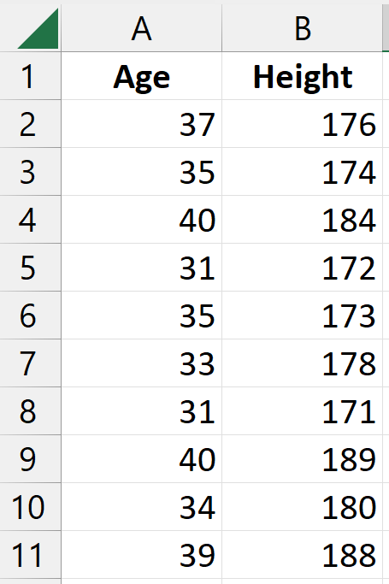
Transcribing the data
- Enter data onto a spreadsheet.
Note: It is good practice to have the tables vertical.
(easier to scroll down than across)

Graphing the data

- Highlight the entire table, including the headers.
- Go to the INSERT tab and click recommended charts.
- Click Scatter and OK

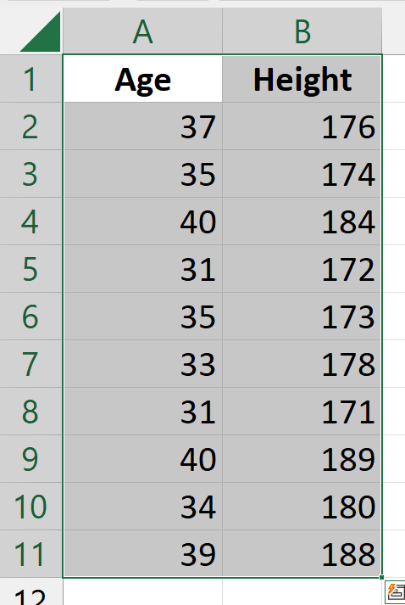

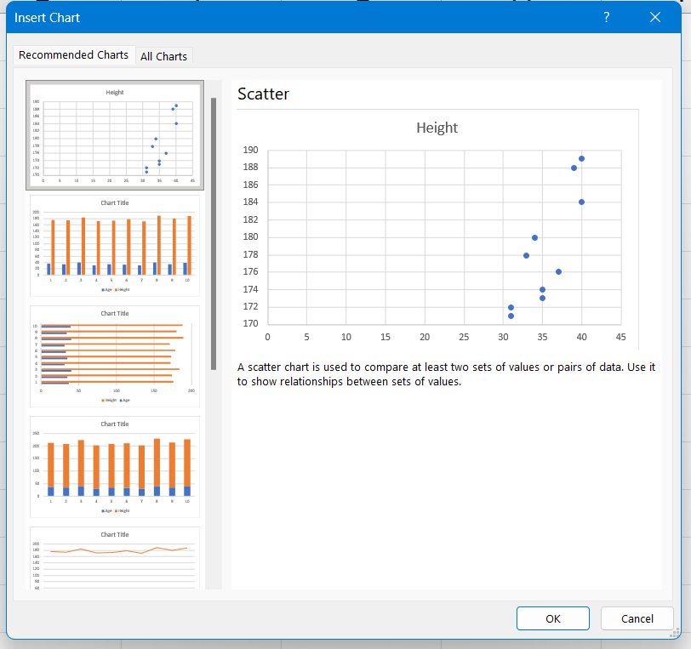

Calculating Pearson’s $r$

- In an empty cell, type $=CORREL($ and highlight the first column.
add a comma $,$ then highlight the second column.
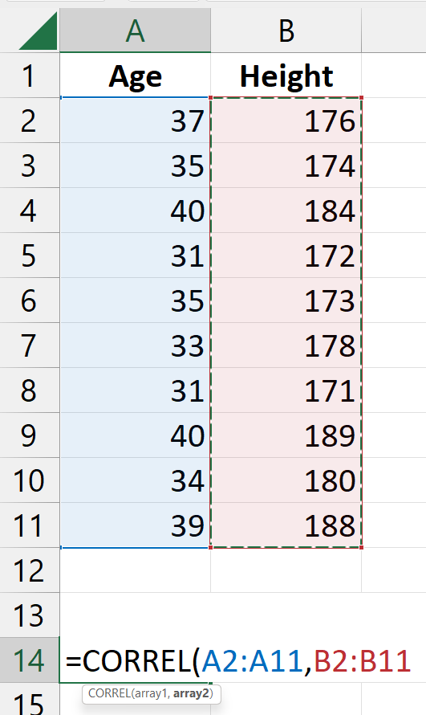
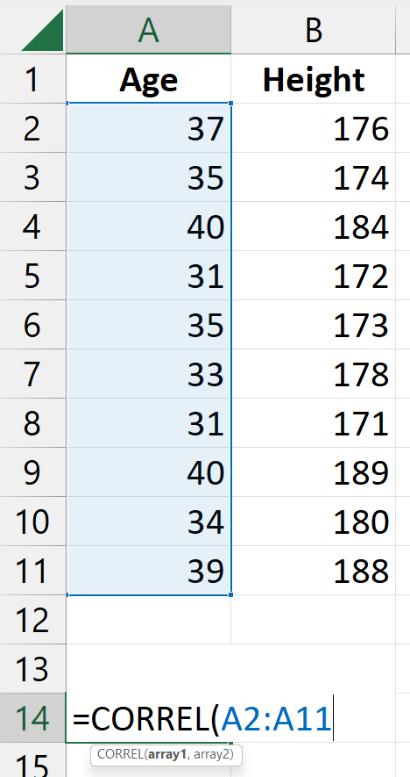

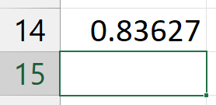
- Press ENTER and the spreadsheet will calculate Pearson’s R

Adding a Regression Line

- Click on your graph.
- Click on the plus $+$ sign to the top right of your graph.
- Click on trendline. This line is called the least-squares regression line. It is a precise line of best fit that is calculated so that the distances of all the points to the line is as small as possible.
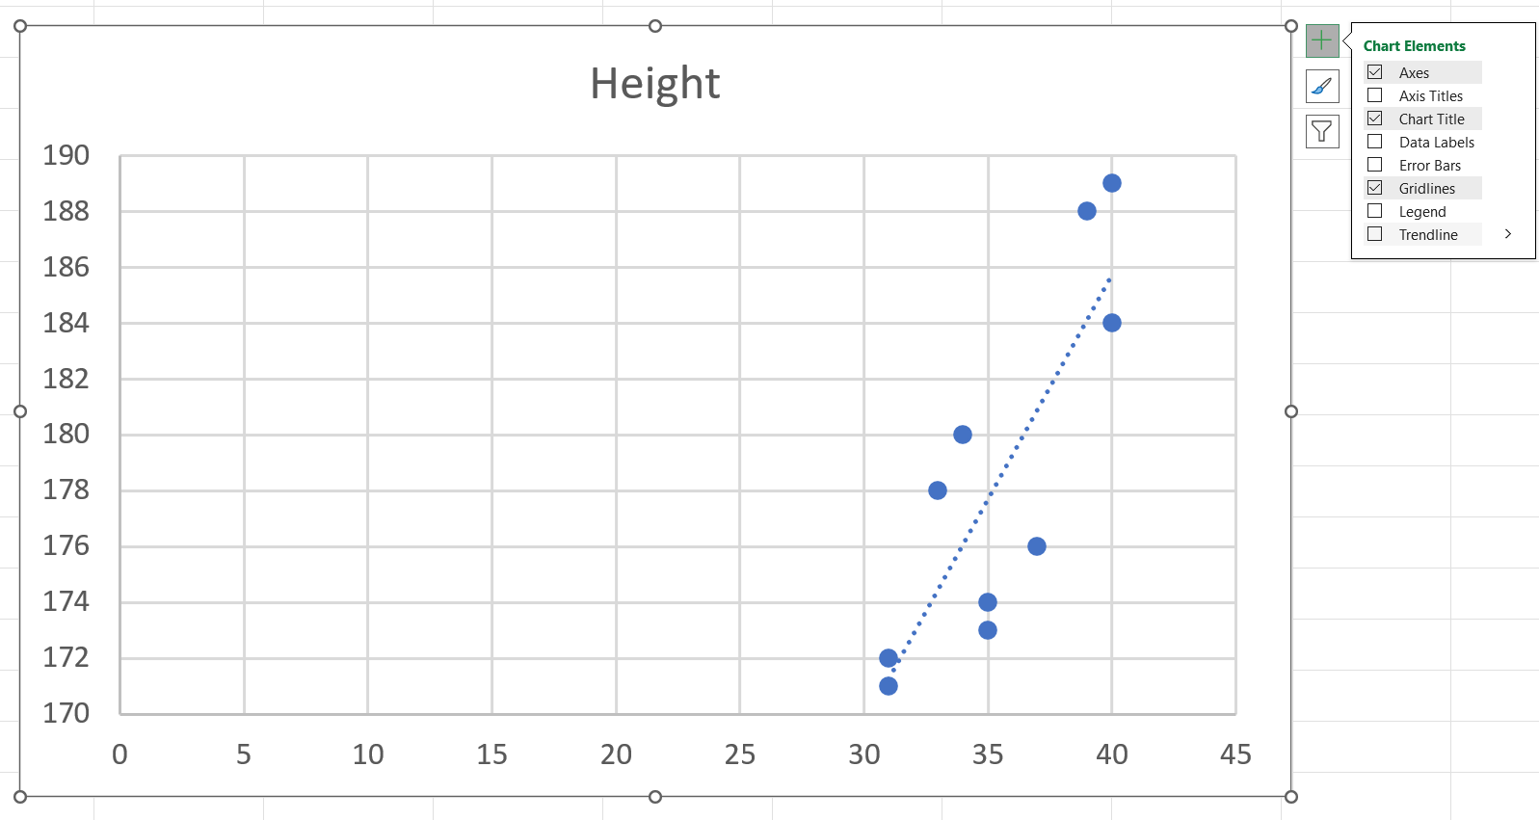

Calculating Equation of the Regression Line
- Right click on the trendline.
- Click format trendline. A sidebar will pop up.
- Click display equation on chart
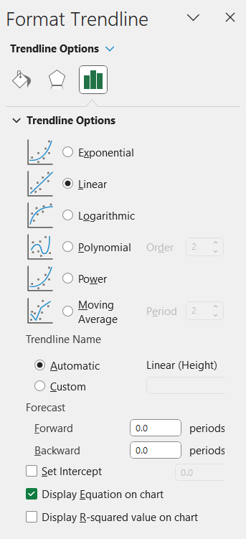
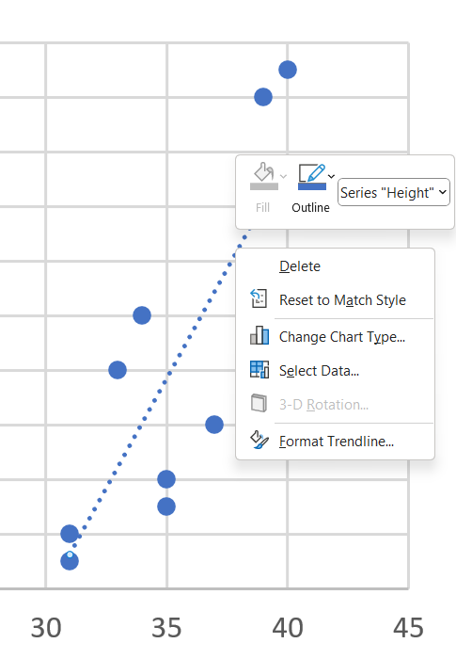

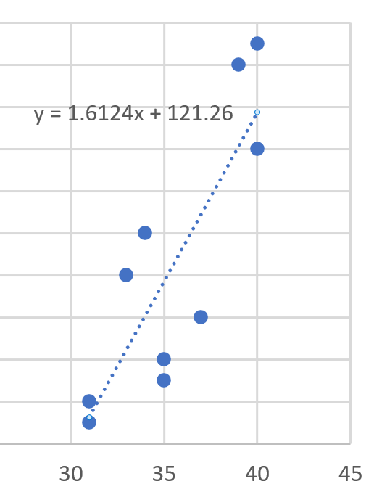

Foundation
- The data shows the average height of 17-year-old girls from 1850 to 1990.
Year | 1850 | 1870 | 1890 | 1910 | 1930 | 1950 | 1970 | 1990
Height (cm) | 147 | 149 | 155 | 158 | 160 | 161 | 164 | 170

- Pearson’s correlation coefficient $r$  0.98264 | - Strength and direction  Strong positive | - Equation of the line of best fit $y=mx+c$  $$y=0.1524x-134.57$$

  - Interpret the gradient and $y$-intercept
Average height of 17-year-old girls increases by 0.1524 cm each year
At the year 0 AD, the average height of a 17-year-old girl is $-134.57$ cm

- The data shows the time students spent studying and their final mark on their exam.
Time studying (h) | 7 | 9 | 14 | 12 | 8 | 3 | 11 | 15 | 5 | 9
Mark | 64 | 67 | 80 | 92 | 73 | 88 | 77 | 89 | 59 | 75

- Pearson’s correlation coefficient $r$  0.44715 | - Strength and direction  Moderate positive | - Equation of the line of best fit $y=mx+c$  $$y=1.3051x+64.262$$

  - Interpret the gradient and $y$-intercept
Mark increases by 1.3051 for each hour spent studying
If you spend 0 hours studying, you will get a mark of 64.262

- The data shows the population of Australia between 1931 and 2011.
Year | 1931 | 1941 | 1951 | 1961 | 1971 | 1981 | 1991 | 2001 | 2011
Population (millions) | 6.53 | 7.11 | 8.42 | 10.55 | 13.07 | 14.92 | 17.28 | 19.27 | 22.34

- Pearson’s correlation coefficient $r$  0.9918 | - Strength and direction  Strong positive | - Equation of the line of best fit $y=mx+c$  $$y=0.203x-386.87$$

  - Interpret the gradient and $y$-intercept
The population increases by 0.203 million each year
The population at 0 AD would be $-386.87$ million

Development
- May is investigating whether there is a link between the weight and systolic blood pressure of several patients at the hospital she works at. She collects the following information.
Weight (kg) | 75 | 83 | 62 | 66 | 98 | 57 | 88 | 111 | 79 | 60
Blood pressure (mmHg) | 99 | 115 | 108 | 86 | 127 | 90 | 122 | 143 | 103 | 105

  - Plot this data as a scatterplot on a spreadsheet.
  - Find the equation of the regression line.
$$y=0.8712x+41.93$$
  - Use the equation of the regression line to predict the systolic blood pressure of patients with the following weights. Round to the nearest whole.
- 115 kg  142 mmHg | - 140 kg  164 mmHg
  - Which of the predictions from part c is more reliable? Explain your answer.

115 kg is only slightly outside the range of existing data so is more reliable.

- June is looking to see whether there is a relationship between the number of goals and behinds in AFL football games. The table below is a sample of the data she collects.
Goals (g) | 14 | 5 | 13 | 15 | 12 | 18 | 17 | 7 | 11 | 25
Behinds (b) | 8 | 15 | 13 | 7 | 8 | 9 | 16 | 9 | 12 | 13

  - Plot this data on a scatterplot, with $g$ on the horizontal axis and $b$ on the vertical axis.
  - Calculate the value of Pearson’s correlation coefficient for the data.
0.02448
  - Considering your answers to b, will the regression line be useful in making accurate predictions for this dataset? Explain your answer.

No. $r=0.02448$ means there is no meaningful relationship between the two variables.

- Investigation Height and Armspan
Measure the height and armspan of the students in your class
(separate results for males and females) and record the information in a table
(or directly into a spreadsheet).
- Draw a scatterplot of the data using a spreadsheet.
- Calculate the value of $r$. Describe the correlation between these two variables in terms of direction (positive/negative) and strength (perfect/strong/moderate/weak).

- Is one variable a good predictor of the other?
- Use technology to add the least-squares regression line of best fit to the data.
- Interpret the gradient and $y$ intercept of your trendline.

- Mr Ding has a height of 181 cm. Predict his armspan.

- Compare your prediction to his actual handspan.
Is his handspan shorter or longer than expected?

- Comment on the validity of your model.

- Investigation Storks deliver babies?
A familiar folk tale is that storks deliver babies, used by parents since ancient times to avoid answering the awkward question “where do babies come from?”

We will investigate whether there is a correlation between storks and birth rate.

Estimated stork population data is available for 17 European countries, shown in the table.
We will compare this to human birth rate.

Country | Storks (breeding pairs) | Human birthrate (10³/yr)
Albania | 100 | 83
Austria | 300 | 87
Belgium | 200 | 118
Bulgaria | 5000 | 117
Denmark | 5 | 59
France | 140 | 374
Germany | 3300 | 301
Greece | 2500 | 106
Holland | 200 | 188
Hungary | 5000 | 124
Italy | 150 | 551
Poland | 30 000 | 610
Portugal | 1500 | 120
Romania | 5000 | 367
Spain | 8000 | 439
Switzerland | 150 | 82
Turkey | 25 000 | 610
- Transcribe the data to Excel and create a scatterplot of Storks ($x$) vs Birthrate ($y$).

- Calculate Pearson’s correlation coefficient between Storks and Birthrate
……………………………………………………………
0.29876
- Comment on the strength and direction of association.

……………………………………………………………
weak positive

From this, you might say:
“The data shows that it’s there is a relationship between storks and babies, maybe storks actually deliver babies!”

We will try to disprove this causal relationship.

Country | Area (km²)
Albania | 28 750
Austria | 83 860
Belgium | 30 520
Bulgaria | 111 000
Denmark | 43 100
France | 544 000
Germany | 357 000
Greece | 132 000
Holland | 41 900
Hungary | 93 000
Italy | 301 280
Poland | 312 680
Portugal | 92 390
Romania | 237 500
Spain | 504 750
Switzerland | 41 290
Turkey | 779 450
A confounding variable is a third variable that influences the two variables of interest.

The area of each country is shown.

Create a scatterplot and calculate Pearson’s $r$
of area vs storks and area vs birthrate.

- Area vs Storks $r$: ……………………………
0.40201
- Area vs Birthrate $r$: ……………………………
0.82742

- Complete the sentences
This study demonstrates that …………… does not necessarily imply ……………
correlation, causation
While there appeared to be a correlation between stork populations and birth rates, further investigation revealed a …………… factor: the …………… of each country.
confounding, area

Read the article and answer the questions:
In the late 1800s, researchers noticed something odd: places with more storks also had higher birth rates. Storks weren't delivering babies. The confounding variable was area. Larger countries have more rural land, storks are more common in rural areas, and rural families tend to have more children. This is a classic example of a spurious correlation: two things that appear related but have no cause-and-effect link.
Correlation does not imply causation. Two things can occur together without either one causing the other.
A common modern example is the claim that violent video games cause aggressive behaviour. There is a correlation between playing these games and aggression, but other factors such as temperament or home environment may explain both the game choice and the behaviour. The correlation alone doesn't establish cause.
In the 1950s, tobacco companies used the same logic when scientists first linked smoking to lung cancer. They argued the relationship might be spurious, just like storks and birth rates. This delayed public understanding of the risk for years.
So how did scientists eventually establish that smoking does cause lung cancer?
They used several independent lines of evidence:
- Large-scale studies showed smokers had far higher rates of lung cancer than non-smokers.
- Laboratory experiments showed cigarette smoke damages DNA and causes mutations.
- Lung cancer risk fell in people who quit smoking.
- Animals exposed to cigarette smoke developed lung cancer.
- A clear dose-response relationship existed: more smoking meant higher risk.
No single piece of evidence was enough on its own. Taken together, they established a causal relationship.
Distinguishing correlation from causation matters in science, policy, and everyday life, and is a common tool in misleading arguments.
What is a spurious correlation? Use the stork example in your answer.

A spurious correlation is when two things appear related but neither causes the other. Storks and birth rates were both linked to a third variable (rural area), not to each other.
Tobacco companies argued that the link between smoking and lung cancer might be spurious. Why was this argument flawed?

The tobacco companies only pointed to one possible explanation without disproving the others. Scientists had multiple independent lines of evidence showing a causal link, including laboratory experiments and dose-response data.
Two students are discussing violent video games. One says: "Studies show that people who play violent video games are more aggressive, so the games must be causing the aggression." What is wrong with this reasoning?

The student is confusing correlation with causation. Other factors, such as temperament or home environment, could explain both the game choice and the aggressive behaviour

